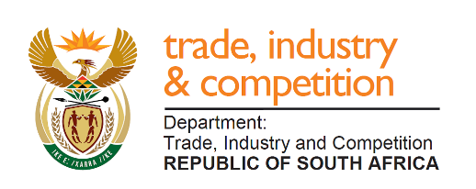

THE NATIONAL ASSEMBLY
QUESTION FOR WRITTEN REPLY
PARLIAMENTARY QUESTION 1719
Ms A M M Weber (DA) to ask the Minister of Trade and Industry:
(1) On what date will the building of the Mulilo Power Station at the SA Energy and Metallurgical Special Economic Zone (SEZ) in Limpopo start;
(2) what is the relationship between the SEZ and MC Mining;
(3) what is the name of each of the six working groups? NW3119E

Reply
I have been advised by the Director General, following consultation with the SEZ concerned, of the following:
- “The SA Energy and Metallurgical Special Economic Zone has no knowledge nor association with building of Mulilo Power Station.

- There is no standing or direct relationship between the Musina-Makhado SEZ and MC Mining, who is not an investor in the Zone.
(3) The titles of the 6 (six) working groups are:
- Governance
- Infrastructure
- Environmental Management
- Investments
- Town Planning
- Skills & Enterprise Development”
In addition to the above information, the honourable Member may wish to follow up further queries with the Province or SEZ concerned.
-END-

