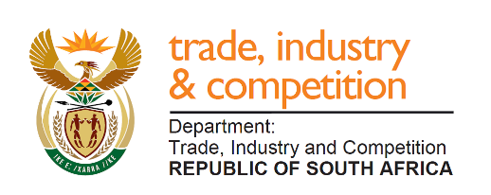

THE NATIONAL ASSEMBLY
QUESTION FOR WRITTEN REPLY
PARLIAMENTARY QUESTION 1718
Ms A M M Weber (DA) to ask the Minister of Trade and Industry:
(1) Whether, with reference to the SA Energy and Metallurgical Special Economic Zone in Limpopo, he will furnish Ms A M M Weber with a copy of the (a) agreement between the President, Mr M C Ramaphosa, and the Chinese government for the investment of R145 billion in the Special Economic Zone (SEZ) and (b) environmental impact assessment for the SEZ Musina-Makhado in Limpopo;
(2) apart from the Chinese government, who are all the investors into the SEZ;
(3) whether there will be any hotel development; if not, what is the position in this regard; if so, (a) who is involved and (b) where will the hotel be built? NW3118E

Reply
I have been advised that there is no agreement between the President and the Chinese government for investment in the SEZ Musina-Makhado. The honourable member may be referring to another agreement and is requested to clarify.

In respect of the environmental impact assessment, the Department reports that the assessment for the metallurgical cluster is currently underway and is targeted for completion in 2020.

The initial investor interest was from Chinese enterprises and it is expected that more enterprises, including locally-owned companies, will be encouraged to locate in the zone. I note that subsequent to the approval of this and other SEZs in past years, Cabinet reviewed the policy around SEZs during the latter part of 2019 and adopted a new approach, which formed the basis for the launch of the Tshwane Auto SEZ-hub and will be utilized in future. This includes a stronger role for national government in ensuring effective and higher-impact Special Economic Zones.

The Department notes that SEZs are aimed at attracting industrial investors and hotels would not be covered by the SEZ-designation in the area.

-END-

