National Assembly
Question No 1717

Ms P Marais (EFF) to ask the Minister of Transport:

What (a) is the extent of potholes in Bloemfontein recorded by his department and (b) total amount would it cost his department to have all the potholes in the specified city fixed? NW2044E

REPLY

(a) The question makes reference to the potholes in Bloemfontein. It is therefore important that roads in an around Bloemfontein are being maintained by The Mangaung Metropolitan Municipality (MMM) as well as the Department of Police, Roads and Transport (DPRT). MMM would therefore be responsible for all urban roads, while DPRT predominantly have custodianship of peri-urban and rural roads. This reply is therefore in relation to the broader Mangaung Metropolitan Area.
It is also important to consider that the MMM relies on the Municipal Infrastructure Grant (MIG) to perform their maintenance, while DPRT relies heavily on the Provincial Roads Maintenance Grant (PRMG) in terms of its maintenance strategies. The PRMG has strict conditions that allows for 25% of the grant to be used for upgrades and the remaining 75% for maintenance activities. This is in contrast with the prevailing road conditions which warrant and require upgrade-related activities, as opposed to the maintenance activities that the grant makes provision for. For this purpose, intense engagement is required from Provincial Treasury to ensure that funding is availed through the Infrastructure Enhancement Allocation for the necessary upgrades. Alternatively, the strict PRMG conditions require relaxation in order for the country at large to be able to mitigate the current backlog in road maintenance. If this is not achieved, Provinces will continuously be challenged with the situation whereby maintenance is performed in line with grant conditions, while the actual need on the ground is much more intense and borders on upgrade activities.

A recent presentation by NDOT suggests that the South African road network was not planned for the current traffic volumes. A large volume of traffic have migrated from rail to road and households currently procure several vehicles as opposed to one vehicle per family as anticipated when the broader road network was planned.

This, as well as the delay of timely routine maintenance activities, contribute to the state in which road are.

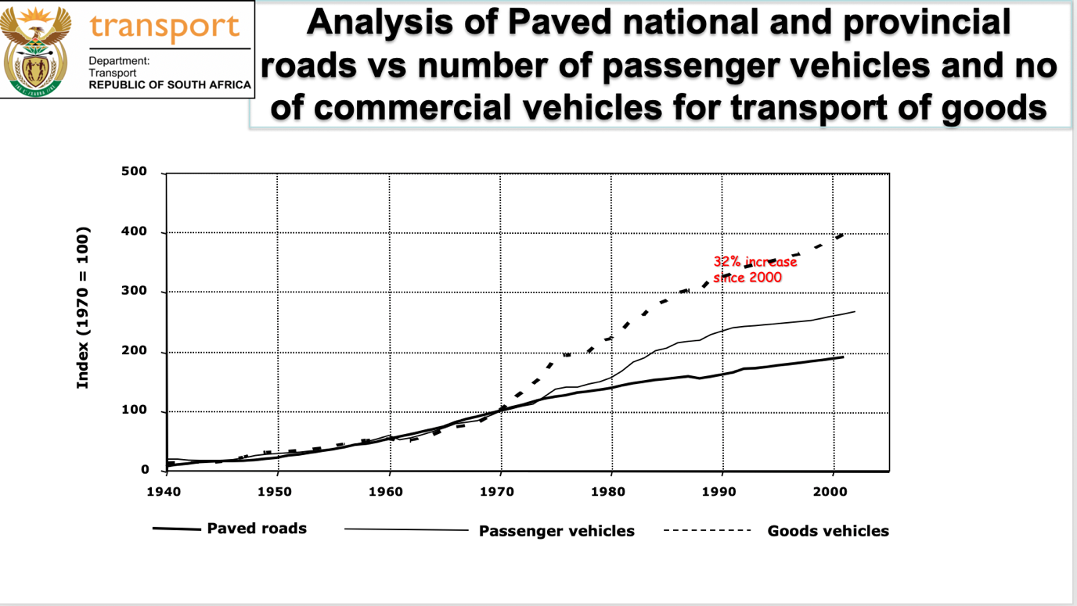

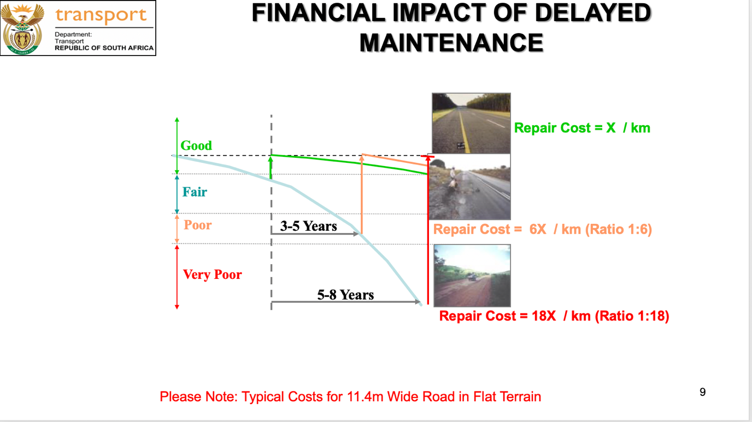
The delay in maintenance, results in exponential repair cost if left unattended.

Information obtained from MMM suggests that their road network within Bloemfontein is as follows:

Mangaung Metro contains a total of 3800km of road network entailing 2200km of unsealed and 1600km of sealed roads.

Conditions are generally poor across most of the areas with about 90% of the bituminous road seal needing urgent attention to prevent moisture ingress and extend the life of the underlying pavement layers.

Rehabilitation backlogs is also substantial with 35% of the pavement layers being in a very poor condition.

Thus, Mangaung Metro Municipality should undertake a project of road network resealing and rehabilitation.

(b) The current conditions requires a total amount of R981 054 417 that will be distributed as follows due to capacity and available budget for the following activities:
  - Rehabilitation of 106km of sealed network
  - Treatment of 335km of sealed network with Micro Paving of 15 mm thick.
  - Replacement of 230km access streets with paving blocks. To avoid high maintenance costs on access roads of functional class 5.
  - Treatment of 30km of sealed network with Asphalt overlay.
  - Application of slurry seals preceded by application of Diluted Emulsion, crack sealing and patching for 149km

The anticipated catch-up period is as follows:

July 2022 to June 2023 R 339 112 210

July 2023 to June 2024 R 272 047 480

July 2024 to June 2025 R 369 894 727

TOTAL R 981 054 417

Similarly, the Department of Police, Roads and Transport have developed a maintenance strategy on its own network consisting of 220km that is being prioritized.
- The estimates are based on current market rates and the available internal maintenance capacity
- Where a service provider is appointed, the cost may differ due to other Logistical and General contractual obligations
- The underlying road pavements of most sections need to be rehabilitated thoroughly to prevent further defects and deterioration.
- The annual Routine Road maintenance must be considered, and have an annual budget allocation to attend ongoing road deterioration. Due to current procurement status of the said Maintenance strategy, costing was done with the aim of addressing it in one financial year as follows:

Description | Amount (R )
Material | R21 331 416,96
Material Transport (10%) | R 2 133 141,69
Labour | R7 250 040,00
Plant & Equipment | R6 849 888,00
Sub Total | R 37 564 486,65
VAT 15% | R5 634 673,00
TOTAL | R43 199 159,65

