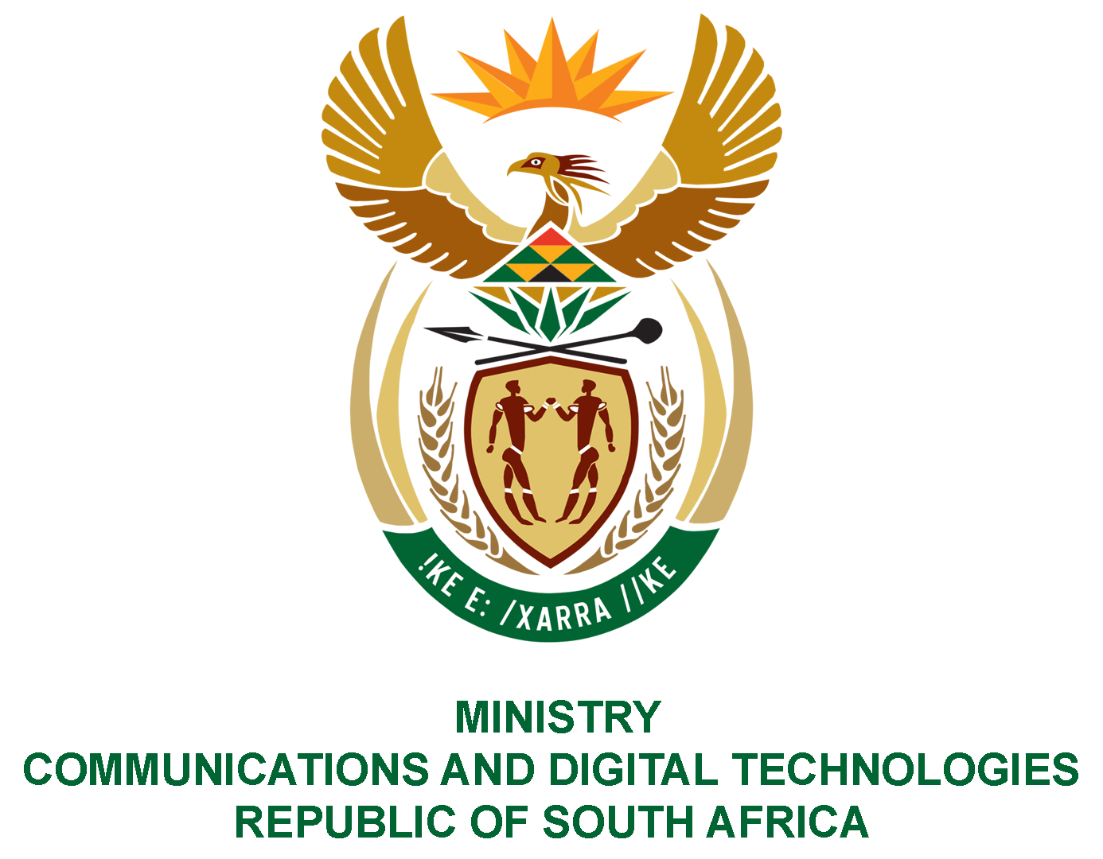

PARLIAMENT OF THE REPUBLIC OF SOUTH AFRICA

NATIONAL ASSEMBLY

WRITTEN REPLY

QUESTION NO: 1717

DATE OF PUBLICATION: 7 JUNE 2021
QUESTION PAPER NO: 16
Mr GG Hill-Lewis (DA) to ask the Minister of Communications and Digital Technologies:
With reference to the directive of the President, Mr M C Ramaphosa, which she refers to in her remarks in Government Gazette No. 42388 of 9 April 2019, that her Office assumes responsibility to oversee and lead the work of the Presidential Commission on the Fourth Industrial Revolution (PC4IR), what are the full details of all fees and monies paid to the (a) individual members of the PC4IR and (b) Chairperson of the PC4IR?
NW1928E
REPLY:
- The Department set aside an amount of R1 650 000, as a once-off gratuity payment to (33) thirty-three PC4IR Commissioners, wherein each Commissioner would receive an amount of R50 000. Of the 33 Commissioners, (6) six were already in employment of the State which eliminated them from receiving the gratuity. In addition, (11) eleven Commissioners opted not to receive the gratuity, while (1) one Commissioner resigned during the beginning of the work of the PC4IR. A total of (15) fifteen Commissioners who complied with the conditions of registration in the Central Supplier Database (CSD) were paid. Accordingly, a total amount of R750 000 was paid to individual members of the PC4IR out of the allocated R1 650 000.

- No payment or fees were paid to the Chairperson of the PC4IR.

MS. STELLA NDABENI-ABRAHAMS, MP
MINISTER OF COMMUNICATIONS AND DIGITAL TECHNOLOGIES

