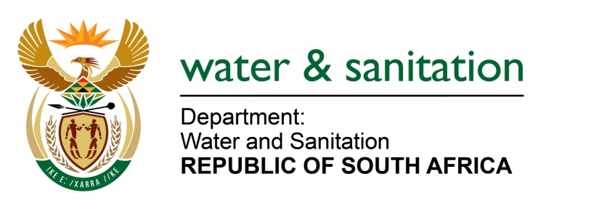

NATIONAL ASSEMBLY

FOR WRITTEN REPLY

QUESTION NO 1716

DATE OF PUBLICATION IN INTERNAL QUESTION PAPER: 26 AUGUST 2016
(INTERNAL QUESTION PAPER NO. 23)

1716. Adv H C Schmidt (DA) to ask the Minister of Water and Sanitation:
Whether any funds allocated to her department for the Sedibeng Regional Sewerage Scheme in the Sedibeng District Municipality in Gauteng by the Presidential Infrastructure Coordinating Committee have been withdrawn; if not, what is the position in this regard; if so, (a) what are the full reasons for the withdrawal of funds and (b) what amount of funding has been withdrawn? NW1965E
---00O00---
REPLY:
- The Sedibeng Regional Sanitation Scheme comprises the upgrade construction of the Sebokeng Waste Water Treatment Works (WWTW), upgrade of the Meyerton WWTW, review of the feasibility study for the possible upgrade of the Rietspruit and Leeuwkuil WWTW, the construction of the Regional WWTW in Sedibeng, as well as the upgrade of the associated bulk collection infrastructure; such as pipelines and pump stations. The Project has not been withdrawn, but is underway and the Sebokeng WWTW and Meyerton WWTW are under construction; and the Sedibeng Scheme is under implementation readiness study.
(b) No amount of money has been withdrawn.
---00O00---

