**NATIONAL ASSEMBLY**

**QUESTION FOR WRITTEN REPLY**

**QUESTION NUMBER: 1715 [NW1866E]**

**DATE OF PUBLICATION: 25 MAY 2018**

**1715. Ms V Ketabahle (EFF) to ask the Minister of Finance:**

(1) (a) What total amount of land owned by the National Treasury and the entities reporting to him in each province is (i) vacant and (ii) unused or has no purpose and (b) what is the (i) location and (ii) size of each specified plot of land;

(2) (a) how much of the land owned by the National Treasury and the entities reporting to him has been leased out for private use and (b) what is the (i) Rand value of each lease and (ii)(aa) location and (bb) size of each piece of land? NW1866E

**REPLY:**

**NATIONAL TREASURY**

1. (a) (i) (ii); (b) (i) (ii) The National Treasury does not own any land.
2. (a) (b) (i) (ii) (aa) (bb) Not applicable

**ASB**

The Accounting Standards Board does not own any land anywhere.

**CBDA**

The Co-operative Banks Development Agency does not own land.

**DBSA**

1. (a( (b) None
2. (a) (b) None

**FIC**

1. (a) (i) none (ii) none (b) not applicable (ii) not applicable
2. (a) none (b) (i) not applicable (ii) (aa) not applicable (bb) not applicable.

**FSCA**

1. The Financial Sector Conduct Authority does not own any land.
2. Not applicable.

**GEPF**

The GEPF owns property and land for investment purposes. Any vacancies in its property portfolio are in the ordinary course of business and may change from time to time. The GEPF invests in vacant land for development purposes. The table below indicates a summary of GEPF’s investments in Property as at 31 March 2017:

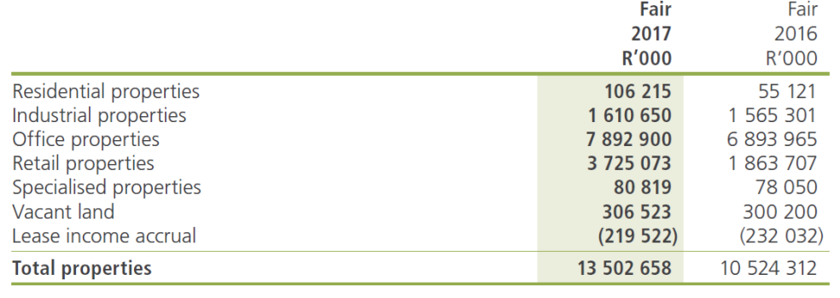

**GPAA**

The Government Pensions Administration Agency does not own any land.

**IRBA**

The IRBA does not own any land.

**LAND BANK**

The list below represent the properties bought in by the Bank due to clients defaulting on their loan payments. The intention of the Bank is to sell these properties to recover the outstanding payments on the defaulted loans. In view of the current volatile market conditions and low property valuations, the properties in possession will only be disposed of as and when conditions render it economically viable. The Bank exclusively hold these properties with a view to dispose of them.

|  | Property address  (i) | Property size  (ii) | Property use  (iii) | Book value as at 31 March 2017  (R) | March 2018 valuation  (R) |  |
| --- | --- | --- | --- | --- | --- | --- |
| BP1938 Pietermaritzburg | Ptn 1 of the farm Klipfontein 31 & Ptn 1 of the farm Weltevreden 182 HT; KwaZulu-Natal Province | 1103.5 ha | Veld grazing land only | 2 800 000 | 6 100 000 |  |
| BP2102 East London | Erven 3946, 3947 & 3949 Dimbaza, Buffalo City Metropolitan Municipality (East London) | 32,562 m2 | Vacant tract of industrial land | 100 | 72 000 |  |
| BP2107 North West | Ptn 93 & Ptn 99 of the farm De Rust 478 JQ & Ptn 17,30 & Rem Ptn 189 of the farm Broederstroom 481 JQ; North West Province | 108.5 ha | The farm is currently utilized as a poultry abattoir and broiler chicken farm. There are no other farming activities. | 41 400 000 | 45 100 000 | Sold to Department of Rural department land reform |
| BP2110 KZN (Valley) | Rem of the Valley Farm 16786 Efunyeni Reserve Empangeni GU; KwaZulu-Natal Province | 235.2 ha | The farm is currently not being utilised with the exception of some nomadic cattle grazing. | 1 650 000 | 1 600 000 |  |
| BP 2112 Pretoria | Ptn 16 of the farm Onspoed 500 JR; Gauteng Province | 21.4 ha | The farm is currently abandoned and not used for any agricultural use. The property is considered to be suitable for grazing. | 500 000 | 500 000 |  |
| BP2114 Saltpeterkranz | Ptn 18 of the farm Salpeterkranz 351 IR; Mpumalanga Province. | 173.8 ha | The farm is currently used by the previous workers for residential purposes and a small portion of cropland with maize at the date of the inspection. | 1 121 000 | 3 060 000 |  |
| BP2115 Limpopo (Portion 1 of Speculatie 139) | Portion 1 (RE) of farm Speculatie 139 LQ. Lephalale Local Municipality; Limpopo Province | 257.8 ha | Unused irrigated farm - tobacco and ground nuts. | 2 005 000 | 4 100 000 | Sold |
| BP2116 Free State | Remainder of the Farm Mond Doornrivier 38 District Theunissen, Portion 10 of the Farm Annex Glen Ross 562 District Bloem. Remainder of the Fram Dankbaarheid 16 District Theunissen, Portion 5 of the Farm Annex Glen Ross 562 District Theunissen ; Free State Province. | 787.5 ha | Farm land and properties. Remainder of the farm Mond van Doornrivier and Portion 10 of the farm Annex Glen Roos has been leased for private use. The monthly rental is R102 147.43. | 464 114 | 12 280 000 |  |
| BP 2117 | Portion 5 remaining extent of Bultfontein and Portion 64 remaining extent of Bultfontein Province of Gauteng | 30.1361  29.3335 | Vacant | 3 870 000.00 | 5 950 000 |  |
| Total |  |  |  | **49 940 214** |  |  |

**FAIS OMBUD**

The FAIS Ombud does not own any land.

**PFA**

The Office of the Pension Funds Adjudicator does not own any land.

**PIC**

The Public Investment Corporation, as an operating entity, does not own any land.

**SAA**

**1. Total immovable property owned by SAA group in South Africa is:**

* **Land size= 1 568 038m²**
* **Improvements/Building area = 373 769m²).**

**See table below for the SAA Property portfolio:**



**2. There is currently no land owned by SAA, being leased for private use.**

**SARS**

1. **SARS does not own any vacant land and owns the following two commercial buildings and seven residential houses only in Gauteng and Free State provinces:**

**Commercial Buildings**

1. Stand 419 Nieuw Muckleneuk, Brooklyn, Pretoria in Gauteng. The land area measures 25,498m². It is used for administrative purposes as SARS Head Office.
2. Consolidated Stand 1087, New Redruth Extension 6, Alberton in Gauteng. The land area measures 56,105m². It is used as Administrative Office Blocks.

**Residential Houses**

1. Stand 799 Ficksburg Extension 20, Free State. The land area measures 1,291m². It is used as residential accommodation (measuring 107m² excluding the outbuildings) for Customs personnel based at Ficksburg land port of entry.
2. Stand 802 Ficksburg Extension 20, Free State. The land area measures 1,122m². It is used as residential accommodation (measuring 107m² excluding the outbuildings) for Customs personnel based at Ficksburg land port of entry.
3. Stand 807 Ficksburg Extension 20, Free State. The land area measures 1,041m². It is used as residential accommodation (measuring 107m² excluding the outbuildings) for Customs personnel based at Ficksburg land port of entry.
4. Stand 842 Ficksburg Extension 20, Free State. The land area measures 1,070m². It is used as residential accommodation (measuring 107m² excluding the outbuildings) for Customs personnel based at Ficksburg land port of entry.
5. Stand 258 Fouriesburg Extension 4, Free State. The land area measures 661m². It is used as residential accommodation (measuring 44m²) for Customs personnel based at Caledonspoort land port of entry.
6. Stand 733 Fouriesburg Extension 4, Free State. The land area measures 851m². It is used as residential accommodation (measuring 125m²) for Customs personnel based at Caledonspoort land port of entry.
7. Stand 748 Fouriesburg Extension 4, Free State. The land area measures 957m². It is used as residential accommodation (measuring 125m²) for Customs personnel based at Caledonspoort land port of entry.

**(2) There is no land leased out by SARS for private use.**

**SASRIA**

1. Sasria does not own any land, and such there is (i) neither vacant (ii) nor unused land.
2. Sasria has not leased out any land owned by National Treasury.

**TAX OMBUD**

1. The Office of the Tax Ombud (OTO) does not own any land.
2. The OTO does not own any land.