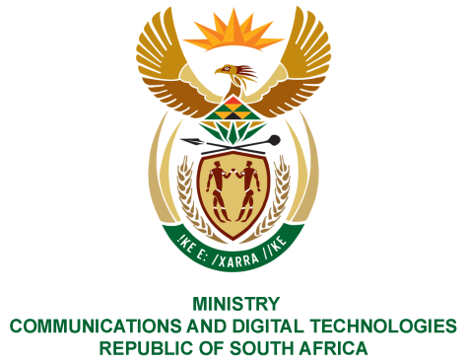
PARLIAMENT OF THE REPUBLIC OF SOUTH AFRICA
NATIONAL ASSEMBLY
WRITTEN REPLY

QUESTION NO: 1713
DATE OF PUBLICATION: 24 July 2020
QUESTION PAPER NO: 28

Mrs N I Tarabella Marchesi (DA) to ask the Minister of Communications:

- Whether, with reference to the reply of the Minister of Basic Education to question 1444 on 13 July 2020, her department requested the Universal Service and Access Agency of South Africa (USAASA) to assist Grade 12 learners by providing locally-produced 32-inch television sets which saw a certain tender (details furnished) being put out; if not, what is the position in this regard; if so, Friday, 24 July 2020 669 INTERNAL QUESTION PAPER: NATIONAL ASSEMBLY NO 28 - 2020 why was the specified tender cancelled only to be put out again under a different reference number;
- Why did USAASA deem it fit to provide television sets to learners instead of other technological devices such as laptops and/or tablets?
- Which areas in the seven provinces are earmarked to receive the specified TV sets?
- By what date does USAASA envisage to complete the whole process from the bidding to the delivery of the television sets to households;
- (a)(i) what total number of Grade 12 learners have applied to receive a television set and (ii) which schools are the learners from, (b) which company and/or companies won the bid to supply the TV sets to Grade 12 learners and (c) for what total amount, including the relevant breakdown of costs, was the tender awarded?

REPLY:

I have been advised by USAASA as follows:

1. The provision of IDTV’s to indigent households with grade 12 learners, but do not have access to a television, is a Covid 19 initiative to assist the most vulnerable Grade 12 learners to keep up educationally with their peers who have more resources.

The provision of a 32-inch IDTV to these indigent households enables the Grade 12 learners to view educational programmes broadcast on SABC channels in preparation for the 2020 matric exams. Tender USAF – IDTV/01/2020 was a multi-facetted tender which was divided into Part A – Establishment of a database of suppliers to supply 32 Inch IDTV’s for indigent households with Grade 12 learners and Part B – Establishment of a database of suppliers to supply 32 Inch IDTV’s for the BDM Phase 2 roll out.

This tender was cancelled for the following 2 reasons: Localisation and local production was not clearly defined in the initial tender which has major economic consequences for South Africa and that the tender was to be split into 2 separate tenders in order to ease the evaluation and adjudication of the tenders and the administration thereof.

The two tenders were published on 12 June 2020 with a closing date of 2 July 2020 in the Tender Bulletin with the Tender Numbers (i) USAF-IDTV/02/2020 and (ii) USAF- IDTV/03/2020

2. The IDTVs were chosen as it is a technology that has already been approved by Cabinet for Phase 2 of the BDM project. IDTVs enable any person to actively participate in TV programs and live debates on key issues that are important for the society as a whole. Thus, transforming a formerly passive device into an active medium for spreading information and opinion. The IDTVs for Grade 12 learners from Indigent households is an early implementation of the Phase 2 of the BDM project and will be continued and phased in to the process. USAASA is therefore not in a position to provide any other technology such as laptops etc, as these will be misaligned to Phase 2 of the BDM project.

3. The IDTVs are intended for indigent households with Grade 12 Learners, who do not have access to a TV, primarily in the following provinces and areas/district as per the attached Annexure A for ease of reference:

a. Limpopo
b. Eastern Cape
c. North West
d. Northern Cape
e. Mpumalanga
f. Free State
g. KZN

4. The tender is currently at the bid evaluation stage. It is envisaged that the tender would be adjudicated in September 2020 and thereafter the distribution of the IDTVs will take effect.

5 (a) (i) USAASA is still in the process of collating lists of qualifying households through the assistance of Department of Basic Education. Application forms have been sent to all the schools as stated in section 3 above. Information is being received from the various schools and is being consolidated. As such, the list of qualifying Grade 12 learners has not yet been finalised.
(ii) The list of schools has not been finalised.
- The tender has not been awarded as yet.
- The final cost of the IDTVs is not yet known as the procurement process is still underway. However, approval was received from National treasury to retain R242 million from accumulated interest from the 2019/20 financial year.

MS. STELLA NDABENI-ABRAHAMS, MP
MINISTER OF COMMUNICATIONS AND DIGITAL TECHNOLOGIES

