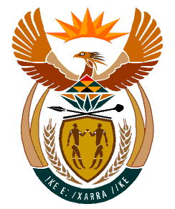

MINISTRY
HUMAN SETTLEMENTS
REPUBLIC OF SOUTH AFRICA

Private Bag X645, Pretoria, 0001. Tel: (012) 421 1309, Fax: (012) 341 8513

Private Bag X9029, Cape Town, 8000. Tel (021) 466 7603, Fax: (021) 466 3610

NATIONAL ASSEMBLY
QUESTION FOR WRITTEN REPLY
QUESTION NUMBER: 1711 [NW203E]

DATE OF PUBLICATION: 06 MAY 2022

1711. Mrs S M Mokgotho (EFF) to ask the Minister of Human Settlements:

By what date will her department allocate houses to the community of Ward 33 in the Moses Kotane Local Municipality which has been waiting for their subsidised houses since 2018? NW2038E
Reply:
The North West Provincial Department of Human Settlements has indicated that it is currently seized with the installation of engineering services. Once completed, housing construction will commence and thereafter qualifying beneficiaries will be allocated houses as soon as construction is completed.

