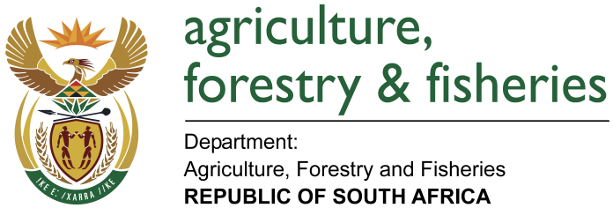
NATIONAL ASSEMBLY

WRITTEN REPLY

QUESTION 1711 / NW 1862E

MINISTER OF AGRICULTURE, FORESTRY AND FISHERIES:
Mr N Paulsen (EFF) to ask Minister of Agriculture, Forestry and Fisheries:

QUESTION:
- What total amount of land owned by his department and the entities reporting to him in each province is (a) vacant and (ii) unused or has no purpose and (b) what is the (i) location and (ii) size of each specified plot of land.

- How much of the land owned by his department and the entities reporting to him has been leased out for private use and (b) what is the (i) rand value of each lease and (ii) (aa) location and (bb) size of each piece of land
REPLY:
- The Department of Agriculture, Forestry and Fisheries (DAFF) does not own land but administers the land on behalf of the Department of Public Works to preserve the land’s agricultural potential. (Attached is table with detailed information – annexure 1).
- ARC is an Entity that owns land reporting to the Ministers (attached as annexure 2).
- All the farms are leased for private use. (Attached is table with detailed information as annexure 2).

