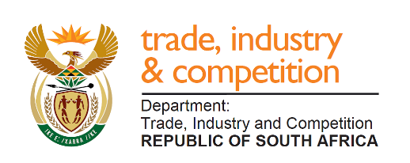
THE NATIONAL ASSEMBLY

QUESTION FOR WRITTEN REPLY

QUESTION 171

171. Mr M J Cuthbert (DA) to ask the Minister of Trade and Industry:
- (a) What total number of Automotive Investment Scheme (AIS) approvals (i) are outstanding and (ii) require approval for the 2018-19 financial year, (b) what are the names of the relevant companies that are still waiting and (c) how long have they been waiting to be approved;
- what has he found to be the economic implications arising from delayed approvals and (b) why have there been any delays in the approval of section AIS incentives;
- what are the details of the (a) of list each AIS incentive transfer that has taken place since 1 April 2017 and (b)(i) amount of the transfer and (ii) the manufacturer concerned;
- (a) whether or not the AIS adjudication committee is in place, (b) how long is their term of office and (c) on what date will the term of the current committee expire? NW192
REPLY
I am advised as follows:
- 45 projects were granted approval under the Automotive Incentive Scheme (AIS) in 2018/19 financial year. All completed applications have been adjudicated as end of the financial year. A list of all approved enterprises and projects across all incentives has been published in the 2018/19 incentive performance report that was tabled in Parliament. The report can also be accessed from the Department’s website: www.thedti.gov.za/publications

- Delays occurred due to lack of information from applicants, internal verification processes as well as late feedback from applicants. The economic implications are that the applicant either continues with the investment or may not invest in line with its business decision.

- In 2017/18 financial year 115 projects were paid a total amount of R1.5 billion and R1.9 billion was paid to 112 projects in 2018/19 financial year.

- The process of appointing adjudication committee members under Department of Trade, Industry and Competition (DTIC) is underway.

-END-

