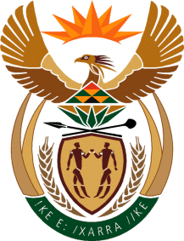

MINISTRY OF TOURISM
REPUBLIC OF SOUTH AFRICA

Private Bag X424, Pretoria, 0001, South Africa. Tel. (+27 12) 444 6780, Fax (+27 12) 444 7027
Private Bag X9154, Cape Town, 8000, South Africa. Tel. (+27 21) 469 5800, Fax: (+27 21) 465 3216

NATIONAL ASSEMBLY:

QUESTION FOR WRITTEN REPLY:
Question Number: 1703
Date of Publication: 24 July2020
NA IQP Number: 28
Date of reply: 29 August 2020

Mr M S F de Freitas (DA) to ask the Minister of Tourism:

With reference to her reply to question 1032 on 8 June 2020, what (a)(i) infrastructure and (ii) facilities have been provided to the Registrar of Tourist Guides since her appointment, (b) is the value of each infrastructure item and facility in each case respectively and (c) were the reasons for the supplying of the infrastructure and facilities in each case? NW2093E

REPLY:

- (i) and (ii) It should be a matter of common understanding that any functionary of government should be provided with the necessary equipment to do their duties and the National Tourist Guide Registrar is therefor no exception.

(b)The Departmentprovides reasonable accommodation and facilities to all its employees in accordance with the guidingpolicies whichequally apply to the National Registrar of Tourist Guides.

(c )To enable the National Registrar to perform her functions both as an official of the Department and as the National Tourist Guide Registrar, facilities were provided in line with her core responsibilities.

