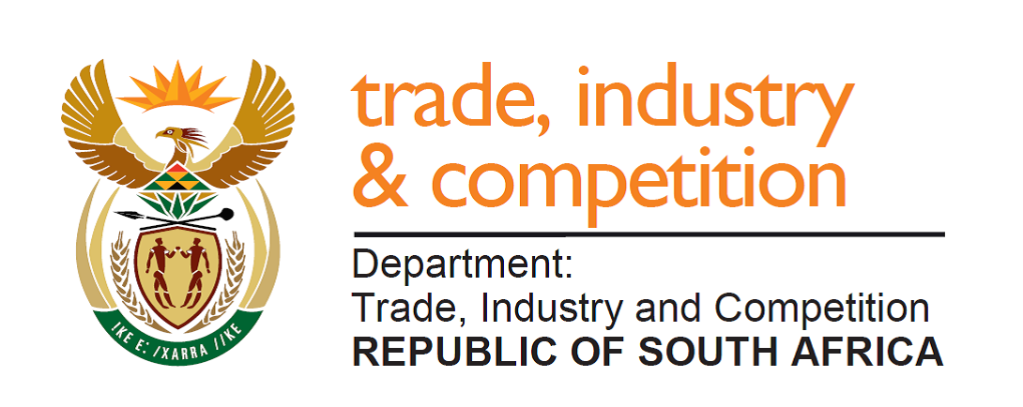

THE NATIONAL ASSEMBLY
QUESTION FOR WRITTEN REPLY
QUESTION 170
Mr MJ Cuthbert (DA) to ask the Minister of Trade and Industry:
- (a) What number of section 12I allowances which (i) are to be considered by the adjudication committee and (ii) have been submitted to his department are outstanding and require approval, (b) what are the relevant details of each company name and (c) how long they have been waiting to be approved;

- (a) what are the economic implications of delayed approvals and (b) why have there been any delays in the approval of section 12I allowances? NW191E

REPLY
Three applications received since 1 February 2020 are to be considered by the Adjudication Committee and five applications are currently being considered. Details of decisions and the identity of companies concerned who receive the incentive are made public once the process is completed.

In two matters, applications being recommended to be declined are being reviewed to check whether they could be approved. One of these may require an opinion from SARS.

As a result of the need to ensure that public funds are deployed to maximum effect to achieve national goals, it has been necessary to review applications carefully for their economic impact and determine whether they fully assist with achievement of such goals.

To illustrate the value of the approach: a recent approval of a s12i application from Hi-Sense, an electronics company located in Atlantis, will now result in improved efficiencies and the creation of a significant number of new jobs. Further details of these will be released in due course.

-END-

