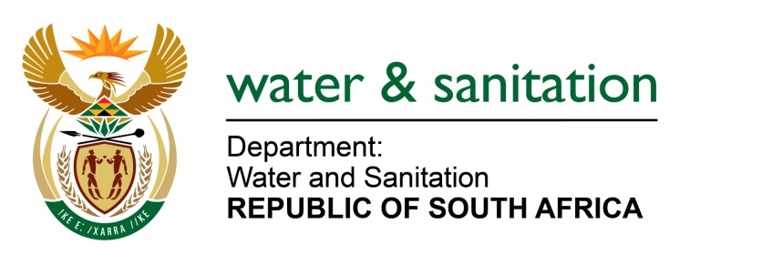

NATIONAL ASSEMBLY

FOR WRITTEN REPLY

QUESTION NO 170

DATE OF PUBLICATION IN INTERNAL QUESTION PAPER: 17 FEBRUARY 2017
(INTERNAL QUESTION PAPER NO. 2)

170. Ms T E Baker (DA) to ask the Minister of Water and Sanitation:
(1) How many water use licences granting abstraction of water from the Hluhluwe River currently exist;
(2) Can she provide Ms T E Baker with a list of the owners of these licences as well as the (a) dates of issue, (b) period for which licence has been granted and (c) volume of water to be abstracted? NW181E
---00O00---
REPLY:
(1) There are currently 2 licences granting abstraction from the Hluhluwe River GWS (SMP 154) that have been registered.
(2) Refer to table below.
Owner of licences | Date issued | Period for licence | Volume of water
UMkhanyakude DM | 2007/05/14 | expiry date 2047/05/13 | 2,806,000m³ annually
Bousaam (Pty) Ltd, licence | 2001/10/24 | expiry date 2021/10/23 | 300,000m³

---00O00---

