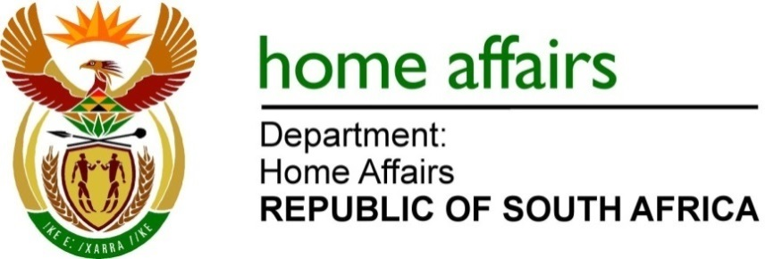
NATIONAL ASSEMBLY

QUESTION FOR WRITTEN REPLY

QUESTION NO.1698

DATE OF PUBLICATION: FRIDAY, 12 MAY 2023

INTERNAL QUESTION PAPER 16 – 2023

1698. Mr J Engelbrecht (DA) to ask the Minister of Home Affairs

Whether he will furnish Mr J Engelbrecht with a comprehensive breakdown of the procurement allocation of (a) his department and (b) every entity reporting to him in terms of the percentages allocated to (i) small-, medium- and micro-enterprises, (ii) cooperatives, (iii) township enterprises and (iv) rural enterprises with a view to evaluating the effectiveness of the set-aside policy of the Government in fostering an inclusive and diverse economic landscape (details furnished) in the (aa) 2021-22 financial year and (bb) since 1 April 2023? NW1939E

REPLY:

Department of Home Affairs and Border Management Authority

- No, the Department has not set aside any specific percentages of its procurement allocation to (i) Small, Medium and Micro Enterprises (SMMEs), (ii) cooperatives, (iii) township enterprises or (iv) rural enterprises in the (aa) 2021/22 financial year and (bb) since 1 April 2023. When issuing bids, the Department targets Broad-based Black Economic Empowerment (BBBEE) Level 1 entities, Emerging Medium Enterprises (EME) or Qualifying Small Enterprises (QSE), 100% Black-owned entities with a preference for Black youth, Black women, or Black people with disability.

- No, the Border Management Authority (BMA) has not set aside any specific percentages of its procurement allocations to (i) SMMEs, (ii) cooperatives, (iii) township enterprises or (iv) rural enterprises in the (aa) 2021/22 financial year and (bb) since 1 April 2023. When issuing bids, the BMA targets Broad-based Black Economic Empowerment (BBBEE) Level 1 entities, Emerging Medium Enterprises (EME) or Qualifying Small Enterprises (QSE), 100% Black-owned entities with a preference for Black youth, Black women, or Black people with disability.
- Government Printing Works

The departmental allocation for respective categories of businesses and applicable financial years is contained in the table below. In line with the below, the Exempted Micro Enterprises (EME) and Qualifying Small Enterprises (QSE) represent small, medium and micro enterprises.

Response | Classification | Total allocation | Percentage
(aa) 2021/2022 Financial Year
b(i) | SMMEs
 | EME | R161 013 937,00 | 3,62%
 | QSE | R477 725 670,00 | 12,57%
b(ii) | Cooperatives | R0,00 | 0%
b(iii) | Township | R6 426 068,00 | 0,14%
b(iv) | Rural | R107 183 843,00 | 2,41%
(bb) April 2023 to Date
b(i) | SMMEs
 | EME | R13 647 717,50 | 0,63%
 | QSE | R53 774 481,74 | 3,36%
b(ii) | Cooperatives | R0,00 | 0,00%
b(iii) | Township | R1 024 610,00 | 0,05%
b(iv) | Rural | R2 859 613,48 | 0,13%

- Independent Electoral Commission

(aa) 2022-23 financial year

Before the introduction of the categorisation of enterprise types by Generic, Qualified Small Enterprises and Exempt Micro Enterprises, the industry norm was to report on SMMEs paying more focus on the number of full-time employees in the entities. The norm as per the current trend is to report on the enterprise types which mainly looks at the categorisation of companies in terms of annual turnover. The advantage of reporting on enterprise type is that information can be verified against Central Supplier Database.

The report below, therefore depicts awards on competitive bidding for the specified period based on the following:
- Generic Entities
- Qualified Entities (QSE)
- Exempt Micro Enterprises (EME)
- Ownership by Black People
- Ownership by Black Youth
- Ownership by Black Women
- Ownership by people living in townships
- BEE Status Levels
- BEE Ownership

It must be noted that the moratorium imposed on procurement in the last financial year as a result of the application of the Preferential Procurement Regulations, 2017 resulted in fewer procurement activities taking place during the period.

BEE or Non-BEE Status

Type | Contract Value |  | Contract %
BEE | R97 713 187 |  | 51%
Non-BEE | R92 638 492 |  | 49%
Total | 190 351 679 |  | 100%

Tenders Awarded by Enterprise Type

Type | Contract Value |  | Contract %
Generic | 100 067 915 |  | 53%
QSE | 7 794 593 |  | 4%
EME | 82 489 171 |  | 43%
Total | R190 351 679 |  | 100%

Tenders Awarded by BEE Contributor Status Level

B-BBEE Contracts | Contract Value |  | % Contract Value
Status Level 1 | R111 510 789,36 |  | 59%
Status Level 2 | R 31 099 606 |  | 16%
Status Level 3 | R 0 |  | 0%
Status Level 4 | R45 437 108,29 |  | 24%
Status Level 5 | 2 304 175,00 |  | 1%
Status Level 6 | R 0 |  | 0%
Status Level 7 | R 0 |  | 0%
Status Level 8 | R 0 |  | 0%
BEE Non-Compliant | R 0 |  | 0%
Total | R 190 351 679 |  | 100%

Black Ownership

B-BBEE Contracts |  | Contract Value
Black People |  | R 144 914 570
Black Youth |  | R 51 286 544
Black Women |  | R 100 860 862
Black with Disability |  | R 0
Ownership by people living in rural or underdeveloped areas |  | R 0
Ownership by people living in townships |  | R 8 894 424

(bb) 1 April 2023 -12 May 2023

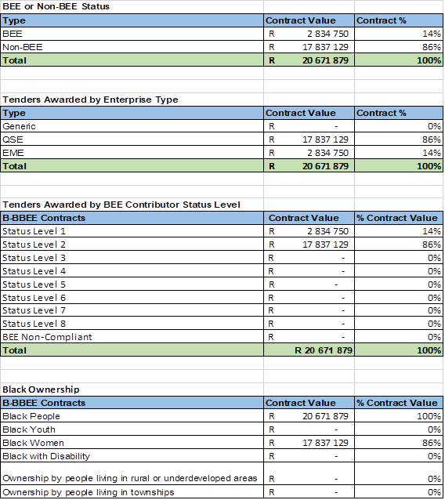

END

