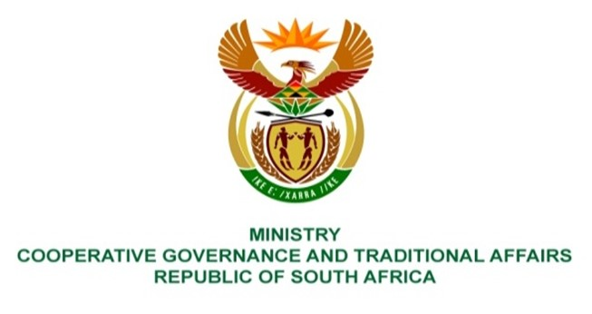

NATIONAL ASSEMBLY
QUESTION FOR WRITTEN REPL

QUESTION NUMBER 1697
DATE OF PUBLICATION: 06 MAY 2022

QUESTION:

1697. Mr P G Moteka (EFF) to ask the Minister of Cooperative Governance and Traditional Affairs:
What measures has her department taken against municipalities, such as the Sekhukhune District Municipality, that have returned money that was meant for service delivery to the National Treasury? NW2022E

REPLY:
It is recommended that the question be transferred to the National Treasury as they have overview of the funds returned by the municipalities, causes of the inability to spend their budgets and the corrective measures to deal with this challenge.

