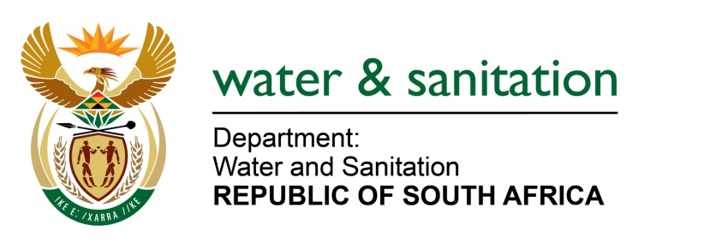

NATIONAL ASSEMBLY

FOR WRITTEN REPLY

QUESTION NO 1697

DATE OF PUBLICATION IN INTERNAL QUESTION PAPER: 26 AUGUST 2016
(INTERNAL QUESTION PAPER NO. 23)

1697. Ms N K Bilankulu (ANC) to ask the Minister of Water and Sanitation:
(a) What is her department’s time frames for (i) commencing with Phase 2 of the Lesotho Highlands Water project and (ii) completing the project, (b) at what stage will the preparatory work, including the appointment of contractors, be completed and (c) what impact will these have on the water resources available to South Africans? NW1943E

---00O00---
REPLY:

(a)(i) The Master Implementation Program, given the status of the Project it is currently, refer to the table below. It should be noted that, the completion of construction dates are dependent on some critical matters such as unforeseen rock conditions encountered when drilling the tunnel since limited geotechnical investigation can be done due to the tunnel alignment being situated very deep below the ground surface.

MASTER IMPLEMENTATION PROGRAM: CRITICAL DATES | Deadlines
Designs of advance Infrastructure commence | Apr 15 – end Sept 18
Award tenders for Polihali Dam design and Polihali Tunnel design | June 17, July 17
Award tenders for construction of Advance Infrastructure | Mar 17 – Oct 20
Award tenders for construction of Polihali Dam and Tunnel | Jul 19, Aug 19
Start impounding water in Polihali dam | May 23
Construction of Polihali Dam complete | Aug 24
Construction of Polihali to Katse Tunnel complete | Jan 25
Water delivery to RSA commence once Transfer Tunnel is complete | End Jan 25

(a)(ii) Delays encountered was due to the evaluating the complex bid documents and the severe adverse weather conditions since most of the work sites are situated high up in the Maluti Mountains.

(b) Refer to table above.

(c) My Department has established a Strategy Steering Committee consisting of all the Major Stakeholders of the Vaal River System (VRS). This Steering Committee is guiding the implementation of various interventions to ensure that there will be enough water in the system until LHWP Phase 2 (Polihali Dam) can deliver water.
-2-

Interventions such as the eradication of unlawful water use, implementation of Water Conservation and Water Demand measures, the desalination and re-use of Acid Mine Drainage, as well as the re-use of sewage return flows.

Although the occurrence of drought is a natural phenomenon causing restrictions to be imposed from time to time, over the medium long-term, the delay in the implementation of Polihali Dam will unfortunately cause periods when the implementation of the above mentioned interventions will not be sufficient to supply enough water which will increase the possibility of unnecessary or pre-mature restrictions in the VRS.

The VRS is currently in a drought situation and it was decided in consultation with the various Stakeholders in the VRS to start the process of implementing progressive water restrictions over the short-term to ensure that a basic water supply can be ensured.

---00O00---

