National Assembly

Question Number: 1696

1696. Mr M S F de Freitas (DA) to ask the Minister of Transport:
(a) What are the details of the Metrorail signal equipment that has been stolen or damaged in the past three financial years, (b)(i) where and (ii) when did such theft and damage take place in each case, (c) what are the respective financial losses in this regard, (d) how were services affected in each province in each month and (e) what is being done to prevent future theft and damage? NW1902E
REPLY
- The stolen or damaged Metrorail signal equipment consists of two elements namely, signal cables and the signal infrastructure. The total number of incidents and arrests are shown below for the Gauteng, Western Cape and Kwa-Zulu Natal Metrorail Regions. This is followed by the tables reflecting the same for the signaling infrastructure. The signaling infrastructure in the Eastern Cape is owned and protected by Transnet.
Signal Cable
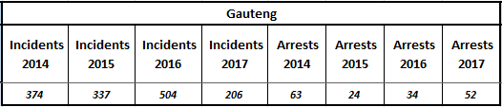
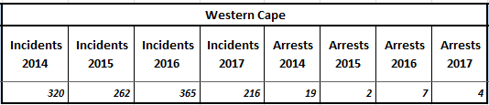
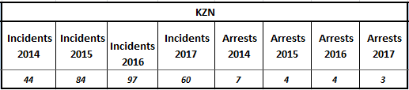
Signal Infrastructure
Gauteng
Incidents 2014 |  | Incidents 2015 |  | Incidents 2016 |  | Incidents 2017 |  | Arrests 2014 |  | Arrests 2015 |  | Arrests 2016 |  | Arrests 2017
477 |  | 317 |  | 220 |  | 121 |  | 145 |  | 53 |  | 34 |  | 32
Western Cape
Incidents 2014 | Incidents 2015 |  | Incidents 2016 |  | Incidents 2017 |  | Arrests 2014 |  | Arrests 2015 |  | Arrests 2016 |  | Arrests 2017
507 | 197 |  | 93 |  | 96 |  | 33 |  | 7 |  | 7 |  | 4

KZN
Incidents 2014 | Incidents 2015 | Incidents 2016 | Incidents 2017 | Arrests 2014 | Arrests 2015 | Arrests 2016 | Arrests 2017
154 | 142 | 66 | 59 | 18 | 2 | 0 | 1

- (i) These incidents occurred in various locations between stations, not always in the same place.
(ii) The time of the incidents varies but most of the incidents occur between the last trains at night and the first trains in the morning.

(c) The total value of operating infrastructure theft and vandalism countrywide amounts to between R25 to R30 million per annum, of which cable theft accounts for R 4-5 million of this total.

(d) It is estimated that between 5 and 10% of trains delays and cancellations is directly related asset related crimes (theft and vandalism). In Gauteng on average 1%, Western Cape 7% and KZN 3% trains are delayed and cancelled due to cable and signaling theft and vandalism.
(e) The following action plans are in place to prevent and reduce the number of occurrences:
From a security perspective the following:
- Crime prevention plans are executed to ensure effectiveness and efficacy in the identified hot spot areas.
- Management of security contracts e.g. (Visits, attending parades, briefings/debriefings, contractor’s meetings, and record keeping).
Enhance all Provincial/Regional security and crime prevention plans to:
- Ensure correct analysis of hot spots areas, trends, times and days
- Correct deployments according to security risk assessments. (May differ from day to day).
- Ensure efficacy of Provincial Rail Crime Combating Forums (PRCCF), Non Ferrous Metal Crime Combating Committees (PNFMCCC) and Provincial Operational Committee (HAWKS POC).
- Implement intelligence driven operations.
- Increase visibility/patrols (Uniforms/Reflectors).
- Arrests must be followed through until conviction. Criminal matters amendment Act no 18 of 2015.
- All cases must be reported to the SAPS to determine crime trends and hot spots.
- Daily monitoring of “hot spots” and “flash points” as defined by the Crime Pattern Analysis.
- Dedicated deployment on hotspots.
- Joint planning between Protection Services and the Rapid Rail Police at the weekly Corridor Railway Crime Combating Forum.
- ADHOC interventions by Rapid Response Units on crime affected areas.
- Stake holders meeting – Rapid Rail Police weekly meeting, Monthly Community Policing Forums and Monthly Commuter meetings.
- Engaging technical department for vandal proofing and burying of signal cable.
- Disruptive scrap metal dealer visits with Fire Arms Liquor and Second-hand Goods Act Component of the Police.

From the engineering side various initiatives are also being implemented to assist with the physical protection of the assets. This includes the following:

- Vandal proofing of cables and infrastructure (burying cables and hardening equipment to make it more vandal resistant)
- Rollout of a GSMR Network (Fibre Optic) to reduce the dependency on copper cables
- Colour light signal lamps changed to light emitting diodes (LED)
- Fencing project – started with the building of walls and fences between stations to keep criminals out/prevent theft.

