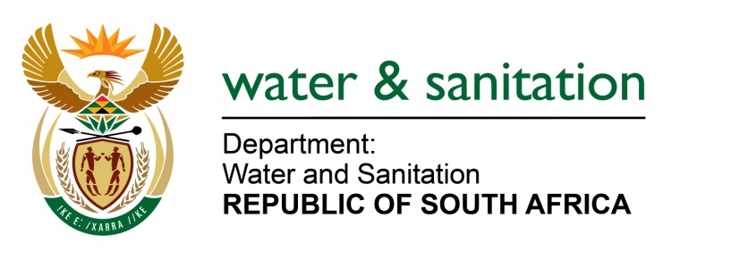

NATIONAL ASSEMBLY

FOR WRITTEN REPLY

QUESTION NO 1695

DATE OF PUBLICATION IN INTERNAL QUESTION PAPER: 19 AUGUST 2016
(INTERNAL QUESTION PAPER NO. 20)

1695. Ms T E Baker (DA) to ask the Minister of Water and Sanitation:
Why was the R43 million tender for a regional water purification plant in the Umzinyathi District in KwaZulu-Natal that was initially awarded to a certain company (name furnished) cancelled and subsequently awarded to another company (name furnished) and (b) what criteria were used to award the specified tender to the specified company? NW1908E

---00O00---
REPLY:
(a) The tender in question was allocated a budget of R34 million and not R43 million. The tender was never awarded to any “certain company” before its cancellation. Out of five of the companies that had been shortlisted in terms of technical functionality, two of them were far above the allocated budget thereof, one was above, and two were far below the allocated budget, which would have compromised the quality of the final product.
(b) A Regulation 32 Appointment was done, with strict adherence to requirements related thereto in order to expedite the process of delivering a water purification plant quickly to the community of uMsinga Local Municipality that is experiencing serious water shortages in this time of drought. The company that was eventually awarded a tender and appointed is currently doing a good job at the cost which is within the allocated budget of the project.
---00O00---

