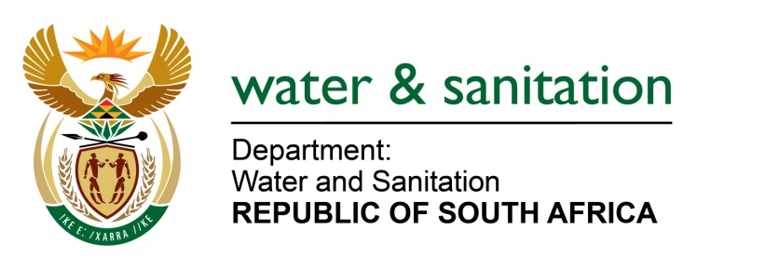

NATIONAL ASSEMBLY

FOR WRITTEN REPLY

QUESTION NO 1694

DATE OF PUBLICATION IN INTERNAL QUESTION PAPER: 19 AUGUST 2016
(INTERNAL QUESTION PAPER NO. 20)

1694. Ms T E Baker (DA) to ask the Minister of Water and Sanitation:
(1) Which municipalities are benefiting from the Accelerated Community Infrastructure Programme in Mpumalanga;
(2) what is the (a) nature of the interventions being implemented, (b) cost thereof and (c) time frames for each of the specified municipalities? NW1907E
---00O00---
REPLY:

(1) The Municipalities benefiting from the Accelerated Community Infrastructure Programme in Mpumalanga are the following:
- Thaba Chweu Local Municipality;
- Dr Pixley ka Seme Local Municipality; and
- Emakhazeni Local Municipality (with 3 projects).
(2) Refer to the table below for the Nature of projects, cost and timeframe for each of the specified municipalities:
Municipality | Nature of the Project/Project Name/ | Cost /Budget allocated for the Financial Year 2016/2017 | Time frame
Emakhazeni LM | Refurbishment of Waterval Boven WWTW and Booster pump stations | R6 365 000 | 6 Months  (March-Nov)
Emakhazeni LM | Refurbishment of Belfast WWTW and Booster pump stations | R8 567 000 | 6 months  (March- Nov)
Emakhazeni LM | Refurbishment of Machadodrop WWTW | R2 000 000 | 6 months  (March-Nov)
ThabaChweu LM | Refurbishment of Lydenburg WWTW | R7 731 000 | 6 months  (March- Nov)
Dr PixleykaSeme LM | Refurbishment of Amersfoort WWTW and Booster pump stations | R3 302 000 | 6 months  (March -Nov)
Total | R27 965 000

---00O00---

