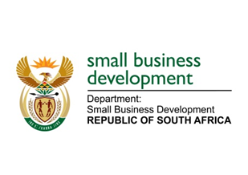
NATIONAL ASSEMBLY
QUESTION FOR WRITTEN REPLY
DUE TO PARLIAMENT: 25 FEBRUARY 2021

169. Mr N E Hinana (DA) to ask the Minister of Small Business Development:
Whether she and/or her department ever received correspondence from a certain political organisation (details furnished), via email, WhatsApp, hardcopy and/or in any other format of which the original file is dated June 2020; if not, what is the position in this regard; if so, (a) on what date was the specified correspondence received, (b) who was the sender of the correspondence and (c) what steps were taken by her department in this regard? NW173E
_________________________________________________________________________________
REPLY:

- Neither the Minister of Small Business Development nor the Department of Small Business Development received the correspondence referred to in the question.

- N/A

- N/A

MS STELLA TEMBISA NDABENI-ABRAHAMS, MP
MINISTER FOR SMALL BUSINESS DEVELOPMENT

