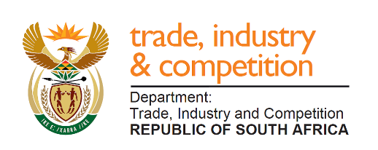

THE NATIONAL ASSEMBLY

QUESTION FOR WRITTEN REPLY

QUESTION 169

Mr MJ Cuthbert (DA) to ask the Minister of Trade and Industry:

(1) With reference to his reply to question 1738 on 7 January 2020, what are the details of the outcomes of the arbitration that took place on 16 and 17 January 2020;

(2) What are the full details of any (a) current and (b) historical financial transactions between his department and EOH Mthambo? NW190E

REPLY

The department has advised as follows:

(1) The matter was concluded on 17 January 2020. All the parties submitted their closing arguments on 31 January 2020 to the GPSSBC as instructed by the Commissioner. The GPSSBC forwarded the closing arguments to the Commissioner on 6 February 2020. I am advised that the employee was found guilty of certain charges by the Commissioner.

(2) (a) There are no current financial transactions.

(b) the dti only processed five (5) payments to the total amount of R11 154 846. Such amount was paid for the milestones that were achieved with details as follows:

Payment | Milestone Achieved | Amount Paid
1 | EOH Invoice Paid: Licencing Cost Support | R5,698,799.02
2 | EOH Invoice Paid: Pilot (MCEP) Phase Initiation | R393,765.12
3 | EOH Invoice Paid: SAP Maintenance Year 1 & 2 | R2,858,517.62
4 | EOH Invoice Paid: Acceptance of Design (Blue print) | R393,765.12
5 | EOH Invoice Paid: Approved Change Request (CR_05) for Additional Requirements | R1,809,999.59

-END-

