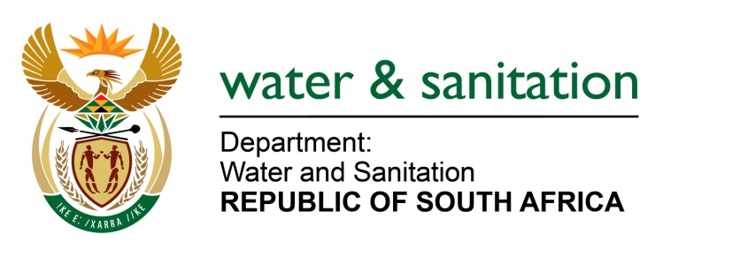

NATIONAL ASSEMBLY

FOR WRITTEN REPLY

QUESTION NO 169

DATE OF PUBLICATION IN INTERNAL QUESTION PAPER: 17 FEBRUARY 2017
(INTERNAL QUESTION PAPER NO. 2)

169. Ms T E Baker (DA) to ask the Minister of Water and Sanitation:
Whether a water use licence has been applied for in respect of the proposed Fuleni Coal Mine; if not, why not; if so, what (a) would be the source of this water and (b) volume has been applied for? NW180E
---00O00---
REPLY:

The applicant has not applied for a Water Use Licence. Water Use Licensing is a demand driven service which is initiated by the prospective applicant.

My Department does not have a Water Use Licence Application for Fuleni Coal Mine, hence it will not be able to determine the source and the volume of water required for the proposed mine.
---00O00---

