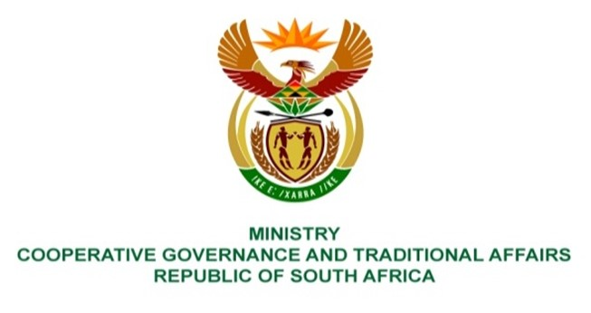

NATIONAL ASSEMBLY
QUESTIONS FOR WRITTEN REPLY

QUESTION NUMBER 2022/1688
DATE OF PUBLICATION:

Ms P Madokwe (EFF) to ask the Minister of Cooperative Governance and Traditional Affairs:
QUESTION:

Following the recent findings by the Special Investigating Unit regarding a service provider (name furnished), that is accused of overcharging the Fetakgomo Tubatse Local Municipality when it was contracted to conduct a R326 million project to electrify 20 000 rural households in 2013, as well as other cases across the Republic, what (a) policies is her department, in collaboration with other departments, putting in place to ensure that municipalities and/or service providers do not waste money on tenders that do not result in effective service delivery, (b) plans have been developed to help municipalities build internal capacity to provide their own services and (c) steps have been taken by her department to recover the monies that the specified service provider had overcharged the specified municipality?

REPLY:
The Honourable Member is requested to refer the question to the National Treasury as they are well positioned to provide response on the issues raised. A number of measures have been put in place by National Treasury aimed at enhancing the tender system to ensure there is value for money.

