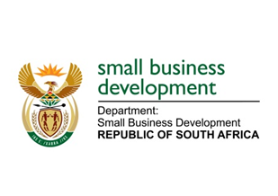
NATIONAL ASSEMBLY
QUESTION FOR WRITTEN REPLY
DUE TO PARLIAMENT: FRIDAY, 26 MAY 2023

“1686. Mr H C C Krüger (DA) to ask the Minister of Small Business Development:
(1) Given the critical importance of prompt payment for the sustainability and growth of small businesses, what (a) measures, (b) strategies and (c) monitoring mechanisms are employed by her department to ensure that all small businesses that are engaged in government procurement activities receive payment within the stipulated 30-day period,
(2) whether there are any remedial actions and/or penalties in place for noncompliant entities and/or departments in cases where payment deadlines are not met; if not, why not; if so, what are the relevant details?” NW1927E

REPLY:

- Given the devastating impact of the non and late payment of small enterprise suppliers by government, the Department following consultations with National Treasury and the Department of Planning, Monitoring and Evaluation (DPME) made recommendations to the Standing Committee on Appropriations and Appropriation Bill, to strengthen the enforcement of compliance to the 30-day payment obligation to ensure that all organs of state will pay invoices to small enterprises within the required timeframe of 30 days. The Department is also working with National Treasury to strengthen regulations on the reporting requirements for the late payment of supplier invoices to differentiate between small enterprise suppliers and large enterprise suppliers. This will enable the Department to specifically follow-up on the late payment of small enterprise suppliers as we do not regulatory authority as it stands.

- We are in the process of amending the National Small Enterprise Amendment Bill that will allow for the establishment of the Ombuds Office which is going to allow for dispute resolutions including nonadherence to the 30-day payment rule.

