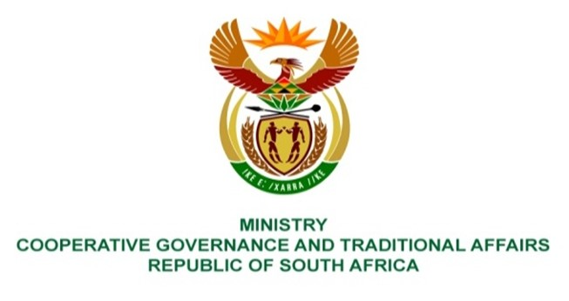

NATIONAL ASSEMBLY
QUESTIONS FOR WRITTEN REPLY

QUESTION NUMBER 1677
DATE OF PUBLICATION: 28 MAY 2021

QUESTION:

1677. Mr C Brink (DA) to ask the Minister of Cooperative Governance and Traditional Affairs:
QUESTION:
What are the
(a) full relevant details of the various agreements signed by her and her predecessors over the past 10 financial years on behalf of the Government with the Republic of Cuba,
(b) reasons and
(c) total amounts paid to any Cuban entity in the past 10 financial years by (i) her department and (ii) any entity reporting to her?

REPLY:
- The Department of Cooperative Governance and Traditional Affairs has not signed any agreements on behalf of the South African Government over the past 10 financial years with the Republic of Cuba.
- The question is not applicable due to the response provided in (a).
- There are no amounts of money paid to any Cuban entities in the past 10 financial years by the Department of Cooperative Governance and Traditional Affairs or any entities reporting to the Minister of COGTA.

