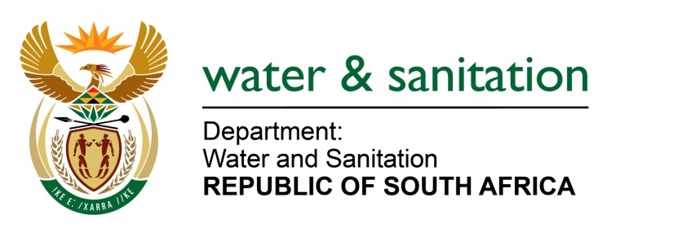

MINISTER OF WATER AND SANITATION

NATIONAL ASSEMBLY
FOR WRITTEN REPLY
QUESTION NO 1675

DATE OF PUBLICATION IN INTERNAL QUESTION PAPER: 29 APRIL 2022
(INTERNAL QUESTION PAPER NO. 15)

1675. Mr L J Basson (DA) to ask the Minister of Water and Sanitation:

(1) What is the nature of the allegations and/or wrongdoing that led to the suspension of the Chief Executive Officer and the Chief Financial Officer of Mhlathuze Water by the Mhlathuze Water Board in December 2021;

(2) whether the specified officials are still suspended; if not, (a) why not and (b) what is the outcome of the investigation; if so, what are the further, relevant details?

NW2003E
---00O00--

MINISTER OF WATER AND SANITATION

- The Chief Executive Officer and the Chief Financial Officer of Mhlathuze Water were put on precautionary suspension on 8 December 2021 following whistle-blower allegations. If proven, these allegations would require the Board to institute a detailed investigation.

- In January 2022, based on the outcome of the preliminary investigation, the Board deemed it appropriate to extend the period of the precautionary suspension for three months with an option of extension for a period not exceeding six months in line with entity’s policy. The two remain on precautionary suspension until the investigation is concluded.

NW2003E

---00O00---

