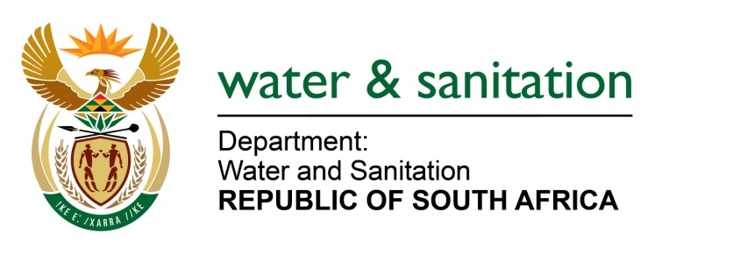

NATIONAL ASSEMBLY

FOR WRITTEN REPLY

QUESTION NO 1674

DATE OF PUBLICATION IN INTERNAL QUESTION PAPER: 29 APRIL 2022
(INTERNAL QUESTION PAPER NO. 15)

1674. Mr L J Basson (DA) to ask the Minister of Water and Sanitation:

(1) Whether the committee appointed by the Mhlathuze Water Board with regard to allegations against a certain office bearer investigated the allegations; if not, why not; if so, what (a) was the outcome of the investigation and (b) are the reasons that he has not appointed an independent authority to investigate the allegations of malfeasance, as per the policy of Mhlathuze Water on whistle-blowing.

(2) whether he will consider dissolving the Board; if not, why not; if so, what are the full, relevant details?

NW2002E
---00O00--

MINISTER OF WATER AND SANITATION
1(a) There is no Committee appointed by the Board of Mhlathuze Water to investigate allegations against the office bearer referred to. The Board cannot appoint a committee to investigate its own affairs. Such powers rest with the Minister of Water and Sanitation. The Ministry has performed a preliminary fact-finding exercise regarding this matter. The department’s Internal Audit will investigate the allegations levelled against the office bearer.

(2) Up until such time that the process outlined above has been concluded it would be premature to speculate on what action the Minister might take.

---00O00---

