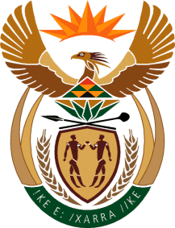

MINISTRY OF TOURISM
REPUBLIC OF SOUTH AFRICA

Private Bag X424, Pretoria, 0001, South Africa. Tel. (+27 12) 444 6780, Fax (+27 12) 444 7027
Private Bag X9154, Cape Town, 8000, South Africa. Tel. (+27 21) 469 5800, Fax: (+27 21) 465 3216

Ref: TM 2/1/1/10

NATIONAL ASSEMBLY:
QUESTION FOR WRITTEN REPLY:
Question Number: 1670
Date of Publication: 29 May 2018
NA IQP Number: 10
Date of reply: 14 June 2018

Mr T W Mhlongo (DA) to ask the Minister of Tourism:
(a) What number of cases relating to the Prevention and Combating of Corrupt Activities Act, Act 12 of 2004, as amended, have been referred to the (i) SA Police Service (SAPS) and (ii) Directorate for Priority Crime Investigation (DPCI) by (aa) his department and (bb) each entity reporting to him for further investigation since the Act was assented to and (b) what number of the specified cases have (i) been investigated by SAPS and DPCI, (ii) been followed up by the respective accounting officers and (iii) resulted in a conviction in each specified finance year since 2004? NW1820E Reply:
(aa) DEPARTMENT
(a) Number of cases referred to the
(i) SAPS: 6
(ii) DPCI: 1 of the 6 referred to SAPS was also referred to DPCI

(b) (i) Investigated by SAPS and DPCI: 1

(ii) Followed up by accounting officer: All 6 cases.

(iii) Resulted in conviction in each specified finance year since 2004:

2004 – 2018 No convictions were made as yet.

(bb) SA TOURISM
(a )(i) SAPS: 1 One case has been referred to SAPS. The matter is still under investigation.

(ii) DPCI: 0

(b) Number of specified cases

(i) Investigated by SAPS and DPCI = 0

(ii) Followed up by accounting officers – N/A

(iii) Resulted in conviction in each specified finance year since 2004 – 2018 N/A

