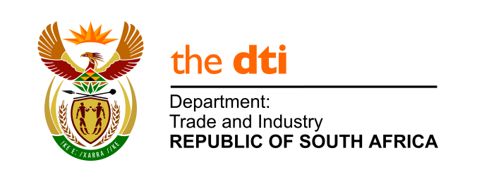

NATIONAL ASSEMBLY

WRITTEN REPLY

PARLIAMENTARY QUESTION 167

DATE OF PUBLICATION: 5 JULY 2019

Mr D W Macpherson (DA) to ask the Minister of Trade and Industry

Whether (a) a certain person (name and details furnished), (b) any family member(s) of the specified person and/or (c) any company, that the specified person is a (i) shareholder or (ii) director of, received any loans from the Industrial Development Corporation since 1 April 2005; if so, (aa) on what date was the loan granted, (bb) to which company or person, (cc) for what amount and (dd) what amount of the loan has been repaid to date in each case? NW1125E.

Reply:

The CEO of the IDC, Mr Tshokolo P. Nchocho, provided the following response to the question:

“The IDC has made funding available to two companies where the person referred to has either a shareholding or directorship therein.
The first company is Ruslyn Minerals (Pty) Limited, in which the person had an indirect shareholding. A loan from the IDC of R6 849 800 was made available in 2006. The company subsequently experienced financial difficulty when a key customer contract was cancelled. To date, the IDC has been repaid R7 982 848.43, which includes accrued interest and fees. An amount of R2 235 746.98 has been written off by the IDC.
The second company is Dartingo Trading 178 (Pty) Ltd, in which the person had an indirect shareholding. A loan of R115 500 000 was made available by the IDC to the company in 2009. The loan was used to purchase a share in a listed company on the ALTX board of the JSE. The company subsequently went into liquidation. As a result, to date no principal has been repaid to the IDC, and the IDC has taken the decision to write off the entire loan amount. The IDC is currently pursuing legal action against the directors of the company for recovery of funds.
Mr Nchocho has further advised that to the best of the IDC’s knowledge, no other funding has been made available to the person referred to, nor any family member.”

-END-

