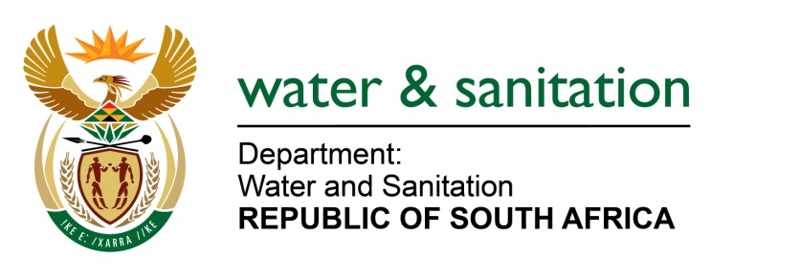

NATIONAL ASSEMBLY

FOR WRITTEN REPLY

QUESTION NO 1668

DATE OF PUBLICATION IN INTERNAL QUESTION PAPER: 9 JUNE 2017
(INTERNAL QUESTION PAPER NO. 21)

1668. Mr L J Basson (DA) to ask the Minister of Water and Sanitation:
Whether any action has been taken against her department’s chief financial officer for incurring over R 2 billion in irregular expenditure in the 2015-16 financial year; if not, (a) why not and (b) will action be taken; if so, what are the relevant details? NW1874E
---00O00---
REPLY:

(a) No, the irregular expenditure that was incurred during the 2015-16 financial year was not incurred by the Chief Financial Officer.

(b) The irregular expenditure was in respect of Regional Bulk Infrastructure Grant (RBIG) and my Department is currently in the process of disciplinary action against the Implementing Agent (IAs) who failed to follow proper Supply Chain Management (SCM) procedures. Furthermore, I am in the process of engaging Water Boards and Municipalities in order to take the necessary corrective action to prevent such further occurrences.

My Department is also in the process of disciplinary action against relevant managers for irregular expenditure of R240 million for goods and services.

---00O00---

