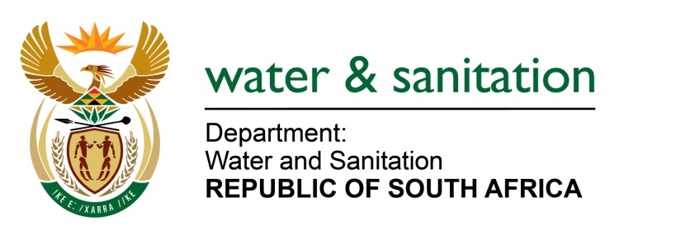

NATIONAL ASSEMBLY

FOR WRITTEN REPLY

QUESTION NO 1668

DATE OF PUBLICATION IN INTERNAL QUESTION PAPER: 9 JUNE 2017
(INTERNAL QUESTION PAPER NO. 21)

1668. Mr L J Basson (DA) to ask the Minister of Water and Sanitation:
Whether any action has been taken against her department’s chief financial officer for incurring over R 2 billion in irregular expenditure in the 2015-16 financial year; if not, (a) why not and (b) will action be taken; if so, what are the relevant details? NW1874E
---00O00---
REPLY:

No, the irregular expenditure that was incurred during the 2015-16 financial year was not incurred by the Chief Financial Officer. The respective managers within my Department who are the budget holders and who signed off on such payments are held responsible for the irregularity of expenditure. Disciplinary action has been/is being taken against the relevant managers.
---00O00---

