

**MINISTRY**

**STATE SECURITY**

**REPUBLIC OF SOUTH AFRICA**

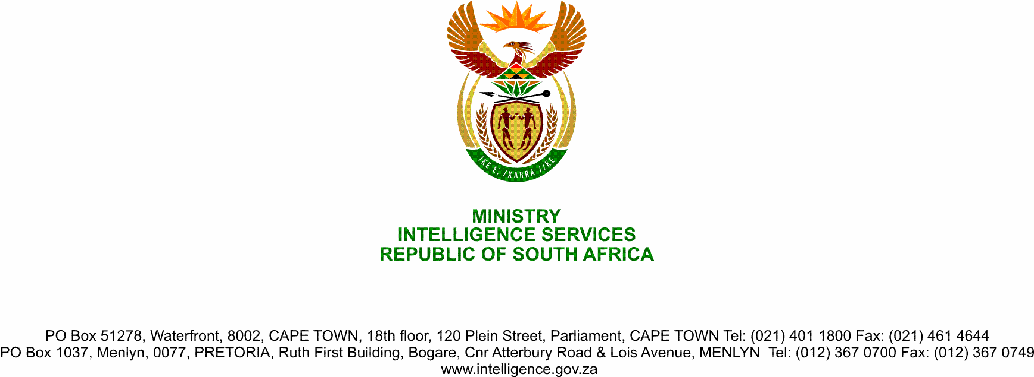

**NATIONAL ASSEMBLY**

**QUESTION FOR WRITTEN REPLY**

**QUESTION NO.: 1666.**

**Dr P J Groenewald (FF Plus) to ask the Minister of State Security:**

(1) What are the criteria for top secret security clearance that is required for a senior appointment in the State Security Agency;

(2) whether Mr Robert McBride attained security clearance and complied with the specified criteria; if so, what are the relevant details;

(3) whether she will make a statement on the matter? NW2056E

**REPLY**

1. The criteria for Top Secret security clearance are multiple and include the successful completion of the vetting process that includes
   1. Verification of the subject’s/applicant’s records as reflected in databases:

* criminal records;
* financial records;
* personal information; or
* any other information that is relevant to determine the security clearance of a person.
  1. The positive outcome following a vetting fieldwork investigation. For a Top-Secret Security Clearance, the process entails the following:

* Full record checks on databases (as mentioned above);
* A subject/applicant interview;
* Two (2) interviews with references;
* One (1) work enquiry; and
* A polygraph examination and evaluation.
  + 1. Regarding the later point, all resultant reports (subject/applicant and combined References’ Interview Report; Investigation Memorandum, and Investigation Diary and Polygraph report.) are then sent to the Evaluation division.

(1.2.2) In assessing the reports, the Evaluator will consider the following in his/her risk summary as per the Legislation:

* Integrity;
* Loyalty to the State and the relevant institution; and
* Non-susceptibility to extortion and blackmail;
* Non-amenability to bribes and non-susceptibility to being compromised due to his or her behaviour or vulnerabilities.

These qualities are critical criteria for employment in a position requiring Top Secret security clearance.

* 1. Based on the Evaluator’s recommendations – emergent from records, interviews and investigations – on whether to issue, degrade, withdraw or refuse to grant a security clearance, the State Security Agency’s (SSA’s) Director-General signs off on the vetting result.

1. Regarding Mr Mc Bride’s security clearance:
   1. On 5 October 2018, the request for the vetting of Mr Mc Bride to the level of a Top Secret level was received from the Independent Police Investigative Directorate (IPID).
   2. His employment at the IPID was later terminated.
   3. On 23 April 2020, the Department of Public Service and Administration (DPSA) requested the SSA to transfer his Top Secret clearance to them.
   4. On 29 June 2020, the SSA Acting Director-General enquired about the progress on the vetting of the said subject.
   5. On 30June 2020, the SSA Human Resource Consultant enquired about the vetting of the said subject.
   6. On 1 July 2020, the subject was contacted to avail himself for a personal interview and it followed all the steps outlined above.
   7. As per the approved Standard Operating Procedure (VA01/2010) on Vetting Fieldwork Investigation, a Polygraph test for a Top-Secret Clearance is required. However, due to the current COVID-19 pandemic, a Polygraph examination could not be conducted, the specific reason being that the procedure would require the Polygraph Examiner to be in close proximity of the subject in a closed area for an extended period; thus exposing them (polygraph examiner/subject) to a possible transmission of the virus.
   8. Nonetheless, given that all the other tests resulted in a positive outcome, the security clearance was issued on condition that as soon as the COVID-19 infection rate flattens, the Polygraph examination will be conducted.
   9. Accordingly, a Top-Secret security clearance procedure was conducted on Mr Mc Bride and a Top-Secret security clearance was issued on the basis of the information currently available to the SSA.
   10. A Top-Secret Clearance was issued on 14July 2020.
2. Not at this stage.