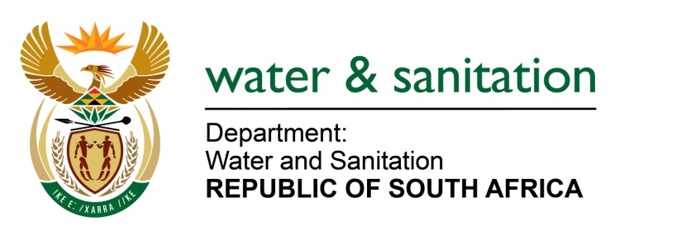

NATIONAL ASSEMBLY

FOR WRITTEN REPLY

QUESTION NO 1666

DATE OF PUBLICATION IN INTERNAL QUESTION PAPER: 9 JUNE 2017
(INTERNAL QUESTION PAPER NO. 21)

1666. Ms T E Baker (DA) to ask the Minister of Water and Sanitation:
(1) Whether the Motau task team which was established by her to investigate procurement transgressions has finalised its work; if not, by what date will the task team finalise its work; if so, what are the relevant details of the findings;
(2) whether she will furnish Ms T E Baker with a copy of the specified task team’s report; if not, why not; if so, by what date? NW1872E

---00O00---
REPLY:
Yes, the Motau Task Team has finalised its work. I am still reviewing the findings of the report and will furnish Parliament with the report in due course.

---00O00---

