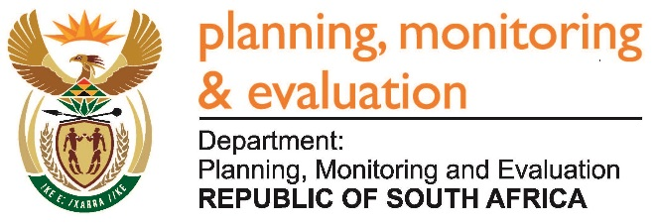 |  | 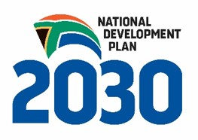
Private Bag X944, PRETORIA, 0001. Union Buildings East Wing, Government Avenue, PRETORIA
Tel: 012 312 0307. www.dpme.gov.za

[No 22—2016] THIRD SESSION, FIFTH PARLIAMENT
______________________
NATIONAL ASSEMBLY

1666. Mr R A Lees (DA) to ask the Minister in The Presidency:

What was the (a) total amount spent and (b) breakdown of such expenditure by The Presidency on its participation in the Commission of Inquiry into Allegations of Fraud, Corruption, Impropriety or Irregularity in the Strategic Defence Procurement Packages to date? NW1878E

REPLY:

The financial statements are prepared by the accounting officer in accordance with Modified Cash Standards prescribed by National Treasury and the requirement of Public Finance Management Act (Act No. 1 of 1999). The financial statements allow the grouping of some transactions and therefore do not allow for identification of transactions that can be related to this question.

