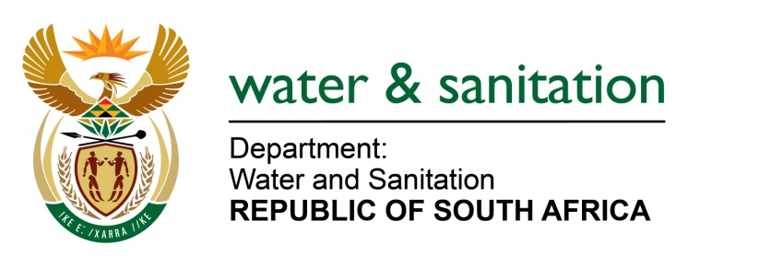

NATIONAL ASSEMBLY

FOR WRITTEN REPLY

QUESTION NO 1665

DATE OF PUBLICATION IN INTERNAL QUESTION PAPER: 9 JUNE 2017
(INTERNAL QUESTION PAPER NO. 21)

1665. Ms T E Baker (DA) to ask the Minister of Water and Sanitation:
What is the (a) nature, (b) cost, (c) location and (d) commencement date of each (i) Accelerated Community Infrastructure project and (ii) Water and Sanitation Implementation Committee project currently under construction. NW1871E
---00O00---
REPLY:

(i) In the 2017/18 financial year, the Accelerated Community Infrastructure Programme (ACIP) will implement 3 projects in the KwaZulu-Natal Province. Refer to the table below for the nature, cost, location and commencement date of each project.

Project Name | (a) Project Nature | (b) Project cost | (c) Location | (d) Commencement date
Manguzi WWTW | Refurbishment of a Waste Water Treatment Work (WWTW) | R 9,710,000 | Umhlabuyalingana Local Municipality (LM) under uMkhanyakude District | October 2017
Hluhluwe WWTW | Refurbishment of WWTW | R3,450,000 | The Big Five False Bay LM under uMkhanyakude DM | October 2017
Ingwavuma WWTW | Refurbishment of WWTW | R13,679,916 | Jozini LM under uMkhanyakude DM | January 2017 (Under Construction)
Total |  | R26,839,916
(ii) There is no programme within my Department’s Branch: National Water Resources Infrastructure implemented as “Water and Sanitation Implementation Committee Projects”.
---00O00---

