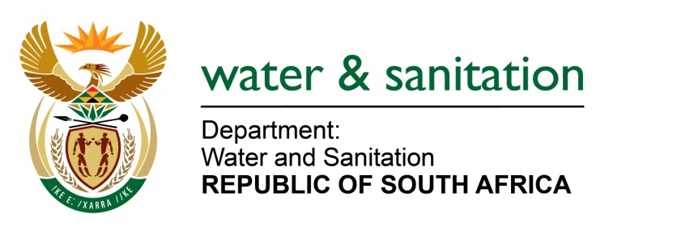

NATIONAL ASSEMBLY

FOR WRITTEN REPLY

QUESTION NO 1664

DATE OF PUBLICATION IN INTERNAL QUESTION PAPER: 9 JUNE 2017
(INTERNAL QUESTION PAPER NO. 21)

1664. Ms T E Baker (DA) to ask the Minister of Water and Sanitation:
With reference to her reply to question 909 on 24 April 2017, (a) what is the total number of service level agreements that have been finalised with municipalities that are in arrears with the various water boards, (b) what are the names of the municipalities and (c) what is the total amount owed by each municipality as at 31 March 2017? NW1870E
---00O00---
REPLY:

(a) There are a total of 47 service level agreements that have been finalised with municipalities that are in arrears with various water boards.

(b) Refer to Annexure A for the names of municipalities.

(c) Refer to Annexure A for the total amount owed by each municipality as at 31 March 2017.

---00O00---

