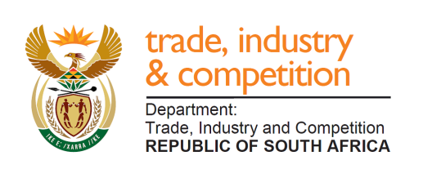

THE NATIONAL ASSEMBLY

QUESTION FOR WRITTEN REPLY

PARLIAMENTARY QUESTION 1663
Mr D W Macpherson (DA) to ask the Minister of Trade and Industry:
What amount of funding did his department contribute towards the March to Freedom exhibition in the City of Cape Town on 15 November 2019 and (b) how has he found did this fulfil the mandate of his department? NW3058E

Reply

I have been advised by officials that the department did not contribute funding to the event.

-END-

