36/1/4/1(201800176)
NATIONAL ASSEMBLY

FOR WRITTEN REPLY QUESTION 1659
DATE OF PUBLICATION IN INTERNAL QUESTION PAPER: 25 MAY 2018 fINTERNAL QUESTION PAPER NO 18-2018)

1659. Mr S C Motau (DA) tO 89k the Minister of Police:

(a) What number of cases relating to the Prevention and Combating of Corrupt Activities Act, Act 12 of 2004, as amended, have been referred to the (i) SA Police Service (SAPS) and (ii) Directorate for Priority Crime Investigation (DPCI) by (aa) his department and (bb) each entity reporting to him for further investigation since the Act was assented to and (b) what number of the specified cases have (i) been investigated by SAPS and DPCI, (ii) been fDllowed up by the respective accounting officers and (iii) resulted in a conviction in each specified financial year since 2004?
NW1809E
REPLY:

The Division: Detective Service, Anti-Corruption Investigation Unit, was established, in 2014/2015. Prior to 2015, cases relating to the Prevention and Combating of Corrupt Activities Act, 2004 (Act No. 12 of 2004), were investigated by the Directorate for Priority Crime Investigation (DPCI).

(a)(i)(aa)

The number of cases referred to the South African Police Service (SAPS), is as follows:

Year Total
2013/2014 "" 1
2014/2015 24
2015/2016 66 i
2016/2017 120
2017/2018 169
1 A r 2018 — 30 A ril 2018 9
YOTAL 389
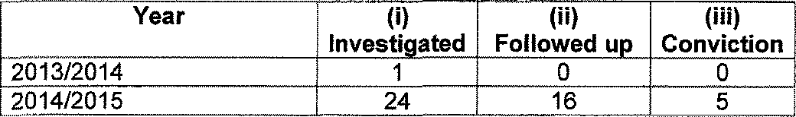
(b)
Year
(i) (ii) (iii)
Investi ated Followed u Conviction

2013/2014 | 1 | 0 | 0
20,14/2015 | 24 | 16 | 5

2

Year | (i) Investigated | (ii) Followed up | (iii) Conviction
2015/2016  2016/2017 | 66  120 ” | 44  70 | 10
 |  |  | 21
2017/2018 | 169 | 64 | 3
1 Apr 2018 — 30 April 2018 | 9 | 0 |  | 0
TOTAL | 389 194 |  | 39

(a)(i)(aa)

Prior to the establishment of the DPCI, in 2009, investigations relating to the PreVention and Combating of Corrupt Activities Act, 2004 (Act No. 12 of 2004), were conducted by the then Commercia! Crime Units, which were part of the Division: Detective Service, within the SAPS.

The number of cases (including reports), which were referred to the SAPS, from 2004 to 2009, is as follows:

2004/2005 | Year | Total  642
2005/2006 |  | 1 520
2006/2007 |  | 2 073
2007/2008 |  | 2 328
2008/2009 |  | 1 931
Total |  | 8 494

(a)(ii)(aa)

The number of cases, which were referred to the DPCI, since the establishment of the DPCI, in 2009, regarding the Prevention and Combating of Corrupt Activities Act, 2004 (Act No. 12 of 2004), is as follows:
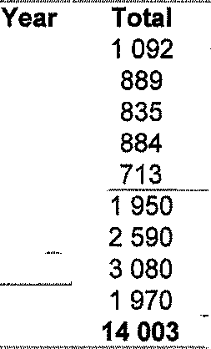

2015/2016
2016/2017
2017/2018
Total
2014/2015
2013/2014
2012/2013
2011/2012
2010/2011
2009/2010

(b)(i)(ii)(iii)

A IabOUr intensiVe and time consuming manual exercise, will be necessary in obtaining this information, thereby necessitating the redeployment of personnel, to gather the required information. This exercise may be to the detriment of essential duties or service to the community, since members will have to be withdrawn from other duties, to be specially allocated to peruse dockets and registers.

The information can only be obtained by the physical perusal of archived files, in order to establish case reference numbers of case dockets, relating to the Prevention and Combating of Corrupt ActiVities Act, 2004 (Act No. 12 of 2004). Correspondence will then have to be directed to all the relevant police stations, country-wide, in an effort to determine the required information of each case, thereby placing an extra burden on limited human and financial resources.

(a)(bb) To be responded to by the other entities, who report to the Minister of
Police.

Reply to question 1659 recommended/

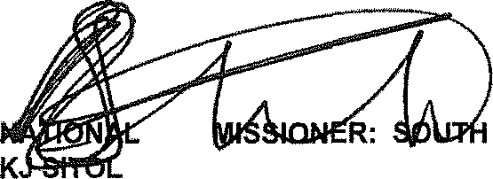
GENERAL AFRICAN POLICE SERVICE

COM
E (SOEG)

Date:

4

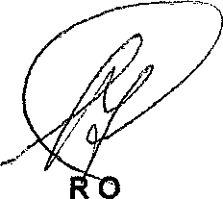
Reply to question 1659 approved/not approved

MINISTE F POLICE BH CELE, MP

