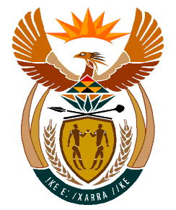

MINISTRY
HUMAN SETTLEMENTS
REPUBLIC OF SOUTH AFRICA

Private Bag X645, Pretoria, 0001. Tel: (012) 421 1309, Fax: (012) 341 8513

Private Bag X9029, Cape Town, 8000. Tel (021) 466 7603, Fax: (021) 466 3610

NATIONAL ASSEMBLY
QUESTION FOR WRITTEN REPLY

QUESTION NUMBER: PQ 1656 (NW 1897E)

DATE OF PUBLICATION: 12 MAY 2023

1656. Mr L Mphithi (DA) to ask the Minister of Human Settlements:

What (a) progress has been reported to her on the investigation on the Khomga Commonage housing project and (b) What steps has her department taken with regard to the specified project since the scandal broke?

Reply:
- According to the Eastern Cape Department of Human Settlements, no investigation has been conducted, safe to indicate that the name of the project is known as Komga Zone 10 Phase 1 housing project.
- The Department is not aware of any scandal regarding the specified project.

