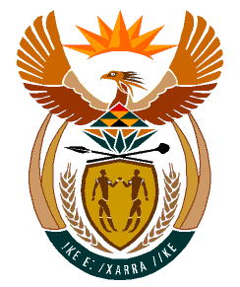

MINISTRY
HUMAN SETTLEMENTS
REPUBLIC OF SOUTH AFRICA

Private Bag X645, Pretoria, 0001. Tel: (012) 421 1309, Fax: (012) 341 8513

Private Bag X9029, Cape Town, 8000. Tel (021) 466 7603, Fax: (021) 466 3610

NATIONAL ASSEMBLY
QUESTION FOR WRITTEN REPLY
QUESTION NUMBER: PQ 1653 (NW1980E)

DATE OF PUBLICATION: 29 APRIL 2022

Ms E L Powell (DA) to ask Minister of Human Settlements:

(1) With reference to the Community Schemes Ombud Service (CSOS) Act, Act 9 of 2011, (a) on what date was the Advisory Council of the CSOS established, (b) what (i) are the names of the members, (ii) are the dates of service and (iii) is the total remuneration amount of each member and (c) where are the minutes of deliberations from establishment to date;

(2) Whether an Advisory Council has been established; if not, what are the reasons that it has not been established; if so, what are the relevant details?

REPLY:

(1) & (2) The appointment of the CSOS Board was prioritised to ensure organisational stability and strategic focus and alignment to the priorities of government.
The appointment of the Sectional Title Schemes Management Advisory Council is in progress and should be finalised by 15 July 2022.

