MINISTER FOR HUMAN SETTLEMENTS: N C MFEKETO, MP DIRECTOR-GENERAL: M S TSHANGANA

NATIONAL ASSEMBLY QUESTION FOR WRITTEN REPLY
QUESTION NUMBER: PQ 1653 (NW1803E) DATE OF PUBLICATION: 25 MAY 2018

REPLY RECOMMENDED BY: S NGXONGO
CHIEF OPERATIONS OFFICER

NATIONAL ASSEMBLY QUESTION FOR WRITTEN REPLY
QUESTION NUMBER: PQ 1653 (NW1803E) DATE OF PUBLICATION: 25 MAY 2018

Mr D J Stubbe (DA) to ask the Minister of Human Settlements:

1. (a) What number of cases relating to the Prevention and Combating of Corrupt Activities Act, Act 12 of 2004, as amended, have been referred to the (i) SA Police Service (SAPS) and (ii) Directorate for Priority Crime Investigation (DPCI) by (aa) her department and, (bb) each entity reporting to her for further investigation since the Act was assented to and (b) what number of the specified cases have (i) been investigated by SAPS and DPCI, (ii) been followed up by the respective accounting officers and (iii) resulted in a conviction in each specified financial year since 2004?

Reply:

Department

1(a) | (i)  (ii) | None.  None
(aa) | (i) | None

- (i) None

  - None

  - None.

However, the National Department of Human Settlements has, over the past three (3) years dealt and/ or conducted investigations into fraudulent payment transactions where some empIoyees/ officials were implicated. There were fi:ve (5) fraudulent payment transactions, with the vaIue/ amounts of between R197 400.00 and R815 326.27.

The five (5) cases implicated the same employees/ officials which were reported to the South African Police Service and registered under the following case reference numbers:

    - Sunnyside CAS 645/09/2014; and
    - Sunny.side PEAS 538/09/2015

The cases are still with the National Prosecuting Authority (NPA).

 | Name of Entity (bb) | (a) Number of cases referred |  | b (i) Number of cases investigated by SAPS & DPCI | b (ii) Number of cases being followed up by Accounting  Officers | b (ui) Number of cases which resulted in conviction  and year
 |  | a(i) SAPS | a(ii) !
 | National Home Builders Registration Council (NHBRC) | 2 cases (222 housing project and fraudulent house settlement claims) | 1 case out of 222 housing project and fraudulent settlement claims | 1 case of Fraudulent house settlement claims | 1 case of Fraudulent house settlement claims | 1 case of Fraudulent house settlement claims led to a conviction in February  2018
 | Community Scheme Ombud Service (CSOS) | Not applicable | Not applicable | Not applicable | 2 cases | No convictions or action as yet as the 2 cases are still under  special audit.
 | Estate Agency  Affairs Board (EAAB) | Not applicable | Not  applicable | Not applicable | Not  applicable | Not  applicable
 | National Urban Reconstruction  Housing Agency | 3 cases  (Attempted fraud by an employee, attempted internet fraud by unknown persons and a case fraud by  supplier) | Not | 1 investigated  by SAPS and 1 still under investigation by SAPS of a supplier | Not  applicable | 1 conviction  of an employee in 2016
 |  |  | applicable
(NURCHA)
Social Housing  Regulatory Authority (SHRA) |  | Not applicable | Not applicable | Not applicable | Not applicable | Not applicable
National Housing Finance Corporation (NHFC) |  | Not applicable | Not applicable | Not applicable | Not applicable | Not applicable
Housing Development  Agency (HDA) |  | Not applicable | Not applicable | Not applicable | Not applicable | Not applicable
Rural Housing Loan Fund tRHLF) |  | Not applicable | Not  applicable | Not applicable | Not applicable | Not applicabJe

NATIONAL ASSEMBLY

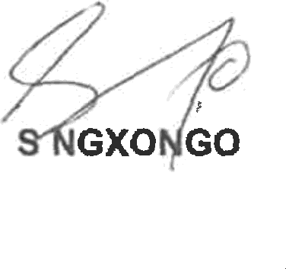
QUESTION FOR WRITTEN REPLY QUESTION NUMBER: PQ 1653 (NW1803E) DATE OF PUBLICATION: 25 MAY 2018

DEPUTY DIRECTOR-GENERAL: CHIEF OPERATIONS OFFICER
DATE: ( +•( OF I / -*/8

N CHAINEE
DEPUTY DIRECTOR-GENERAL: STRATEGY AND PLANNING
DATE:
Recommended/not re
mended

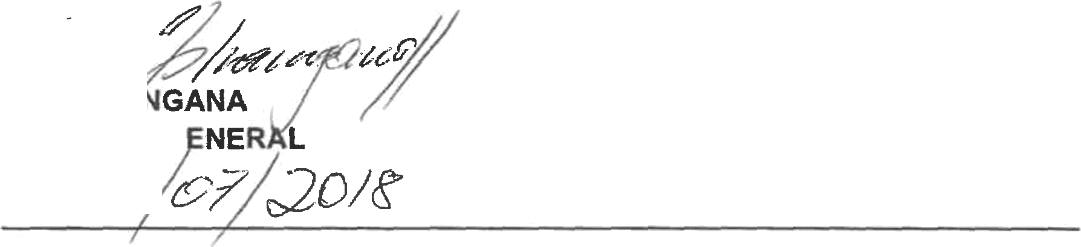,

M S ’HP DIRECTOR-G DATE:

Approved/not approved

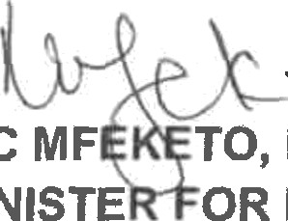N C MF TO, MP
MINISTE OR HUMAN SETTLEMENTS
DATE:

