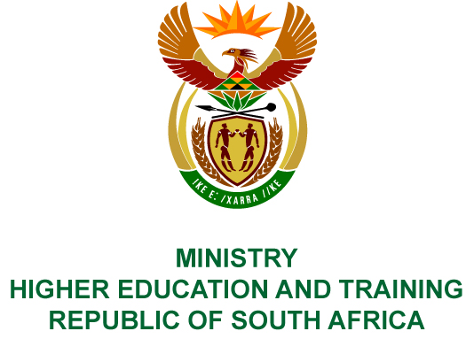
Private Bag X893, Pretoria, 0001, Tel (012) 312 5555, Fax (012) 323 5618
Private Bag X9192, Cape Town, 8000, Tel (021) 469 5150, Fax: (021) 465 7956
Memorandum from the Parliamentary Office
NATIONAL ASSEMBLY
FOR WRITTEN REPLY
QUESTION 1651
DATE OF PUBLICATION OF INTERNAL QUESTION PAPER: 25/05/2018
(INTERNAL QUESTION PAPER NO 18 OF 2018)
Mr P van Dalen (DA) to ask the Minister of Higher Education and Training:
(a) What number of cases relating to the Prevention and Combating of Corrupt Activities Act, Act 12 of 2004, as amended, have been referred to the (i) SA Police Service (SAPS) and (ii) Directorate for Priority Crime Investigation (DPCI) by (aa) her department and (bb) each entity reporting to her for further investigation since the Act was assented to and (b) what number of the specified cases have (i) been investigated by SAPS and DPCI, (ii) been followed up by the respective accounting officers and (iii) resulted in a conviction in each specified financial year since 2004?
NW1801E
REPLY:
- (i) Since the Department of Higher Education and Training became operational on 1 April 2010, six cases were referred to the South African Police Services for further investigation comprising two from the Department and four by public entities based on the information submitted to date.
- The Department referred no matters to the Directorate for Priority Crime Investigations, while the public entities referred four cases for investigation.
- (i) Both the Departmental and three of the eight public entity cases have since been investigated by the South African Police Services and Directorate for Priority Crime Investigations.
(ii) In respect of the Department, one of the two cases has been followed up by the Accounting Officer, while the second matter is currently under investigation. The public entity cases are still under investigation.
- None of the investigations has resulted in convictions to date.

