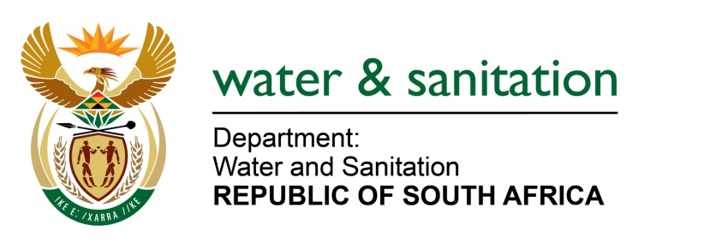

NATIONAL ASSEMBLY

FOR WRITTEN REPLY

QUESTION NO 1649

DATE OF PUBLICATION IN INTERNAL QUESTION PAPER: 29 APRIL 2022
(INTERNAL QUESTION PAPER NO. 15)

1649 Mr C Brink (DA) to ask the Minister of Water and Sanitation:
Whether he has found that most of the waste water treatment plants and sewage pumping stations in municipalities in the Free State and the North West are either completely non-functional and/or operating at diminished capacity; if not, will he, in collaboration with the relevant departments, undertake an assessment of what total number of the plants and/or stations are functional and operating at full or near full capacity and report its findings to Parliament; if so, what is he, in collaboration with the relevant departments, doing to ensure that (a) existing sewage infrastructure is refurbished and (b) any capital expenditure allocated towards the purpose is not misappropriated?
NW1976E
---00O00---
MINISTER OF WATER AND SANITATION

The Department of Water and Sanitation (DWS) revived the Green Drop programme in the 2021/2022 financial year. The Green Drop regulation programme sought to identify and develop the core competencies that, if strengthened, would gradually and sustainably improve the standard of wastewater management in South Africa. The Green Drop programme seeks to induce changes in behaviour of individuals and institutions to facilitate continuous improvement and adoption of best practice management of wastewater networks and treatment systems. The programme evaluates the entire wastewater management services over a one-year audit period. The Green Drop report was released on 1 April 2022, and it can be accessed on the departmental website www.dws.gov.za.

In the Green Drop report, it has been indicated that 64 (FS) and 33 (NW) Wastewater Treatment Systems have been identified to be at critical state in the Free State and Northwest Provinces respectively. The table below provides details systems at critical state in the two provinces. Letters of non-compliance in terms of green drop report audit findings have been sent to respective water services authorities responsible for the systems at critical state, requiring them to submit a detailed corrective action plan to the DWS.

Table of Systems at critical state in Free State and Northwest provinces
FREE STATE PROVINCE | 64
Kopanong LM | 4
 | Fauresmith
 | Gariep Dam
 | Jagersfontein
 | Reddersburg
Letsemeng LM | 2
 | Koffiefontein
 | Oppermansgronde
Mafube LM | 5
 | Namahadi
 | Villiers/Qalabotjha
 | Frankfort
 | Tweeling
 | Cornelia
Maluti-a-Phofung LM | 7
 | Elandsriver
 | Kestell
 | Makwane/Matsegeng
 | Moeding
 | Phuthaditjhaba
 | Tshiame
 | Wilge/Harrismith
Mangaung LM | 6
 | BFN - Northern Works
 | BFN-Bloemdustria
 | Soutpan
 | Dewetsdorp
 | Van Stadensrus
 | Wepener
Mantsopa LM | 3
 | Excelsior
 | Ladybrand
 | Tweespruit
Masilonyana LM | 3
 | Brandfort
 | Theunissen-Masilo
 | Winburg
Matjhabeng LM | 10
 | Allanridge
 | Hennenman
 | Mmamahabane
 | Odendaalsrus
 | Phomolong
 | Thabong
 | Theronia
 | Ventersburg
 | Virginia
 | Witpan
Mohokare LM | 3
 | Rouxville
 | Smithfield
 | Zastron
Nala LM | 3
 | Bothaville
 | Wesselsbron
 | Monyakeng
Ngwathe LM | 5
 | Parys
 | Vredefort
 | Koppies
 | Heilbron
 | Edenville
Nketoana LM | 1
 | Lindley/Ntha
Phumulela LM | 3
 | Vrede
 | Warden
 | Memel
Setsoto LM | 3
 | Ficksburg
 | Clocolan
 | Marquard New
Tswelopele LM | 1
 | Hoopstad
Moqhaka LM | 3
 | Kroonstad
 | Steynsrus
 | Viljoenskroon
Metsimaholo LM | 2
 | Deneysville-Refengkgotso
 | Oranjeville

NORTHWEST PROVINCE | 33
Dr Ruth Mompati DM | 8
Naledi LM | Vryburg
Mamusa LM | Schweizer Reneke
Naledi LM | Stella
Greater Taung LM | Taung Hospital
 | Taung Station
 | Diplankeni/Mogogong
 | Maganeng/Pudimoe
 | Reivilo
Kgetleng River LM | 4
 | Koster AS
 | Swartruggens
 | Koster Ponds
 | Mazista
Madibeng LM | 3
 | Mothotlung
 | Eagles Landing
 | Sunway
Maquassi Hills LM | 2
 | Leeudoringstad
 | Wolmaranstad
Moretele LM | 1
 | Swartdam
Moses Kotane LM | 2
 | Mogwase
 | Madikwe
Ngaka Modiri Molema DM | 13
Ditsobotla LM | Coligny
 | Lichtenburg
 | Itsoseng
Mafikeng LM | Mahikeng
 | Mmabatho
Ramoshere Moilwa LM | Lehurutshe-Welbedacht
 | Zeerust
Tswaing LM | Delareyville
 | Sannieshof
 | Ottosdal
 | Atamelang
 | Groot Marico
 | Itekeng Ponds

- The department will from the financial year 2022/2023 onwards, through the Water Service Infrastructure Grant (WSIG) prioritise the approval of business plans from municipalities designed to refurbish and upgrade the diminishing wastewater treatment works. It should be noted that the department provides funding to municipalities for upgrading and refurbishing wastewater treatment works through the Water Service Infrastructure Grant and Regional Bulk Infrastructure Grant (RBIG) on an ongoing basis. The department will continue supporting municipalities in collaboration with CoGTA, to ensure that the wastewater treatment works are complaint with the required standard in line with the green drop requirements.

- The department allocates grants in line with the approved business plans of WSAs. The business plans are followed by supporting documentations such as cashflows and project plans documents. The department further allocates funds in terms of direct transfers and indirect transfers to municipalities. The department will monitor the expenditure of the grants to ensure that funds are not misappropriated. The department will further enforce Division of Revenue Act to ensure that the grant funding is spent in line with the requirements of the Act. Where there is misappropriation, required actions will be taken in line with the Act itself.

---00O00---

