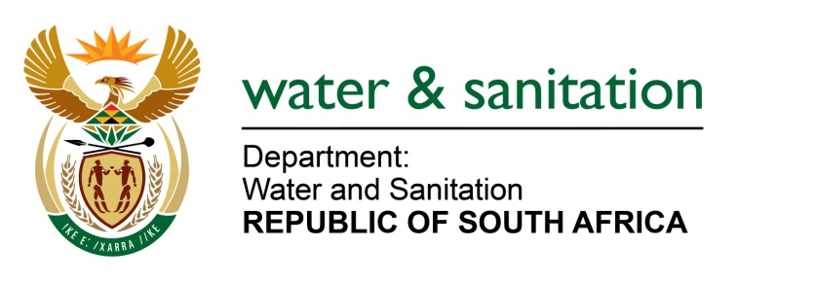

.

NATIONAL ASSEMBLY

FOR WRITTEN REPLY

QUESTION NO 1649

(INTERNAL QUESTION PAPER NO.16)

1649. Ms E L Powell (DA) to ask the Minister Water and Sanitation:

Whether she will provide Ms E L Powell with the full, relevant details on the (a) dates, (b) destinations and (c) costs of all flights boarded by a certain person (Mphumzi Mdekazi) (i) between 1 May 2019 and 1 October 2020 and (ii) during the National State of Disaster period; if not, why not; if so, what are the relevant details NW1855E
---00O00---

THE MINISTER OF WATER AND SANITATION

The Department incurred the following costs in relation to Mr Mdekazi for the period 1 May 2019 and during the National State of Disaster period :

Category | Cost
Accommodation/ domestic air travel/ Car hire and transfers | R 1 763 878.00

---00O00---

