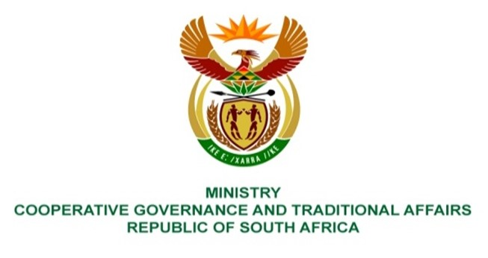

NATIONAL ASSEMBLY
QUESTIONS FOR WRITTEN REPLY

QUESTION NUMBER
DATE OF PUBLICATION: 29 APRIL 2022

QUESTION:

1648. Mr C Brink (DA) to ask the Minister of Cooperative Governance and Traditional Affairs:
Whether she has been informed that sanitation infrastructure built by a certain company (name furnished) on contract to the Mangaung Metropolitan Municipality around 2019 in Zone 1 of Thaba Nchu in Ward 41 of the specified municipality has collapsed and/or is otherwise defective, leading to sewage spills in the community; if not, will she (a) intervene to assist the municipality to take remedial action and/or (b) report on the progress of refurbishing the infrastructure; if so, what measures are being taken by her department to assist the municipality to remedy the situation? NW1975

REPLY

This and other poor service delivery issues of Mangaung Metropolitan Municipality (MMM) were brought to our attention.

- To that end Cabinet approved an intervention in terms of section 139 (7) of the Constitution of the Republic of South Africa 1996 aiming to create stability and improve service delivery. DCOG is in the process of appointing senior managers as was highlighted in the background above.

- It is expected that the acting senior personnel, including the Acting Municipal Manager and Acting Engineering Services Head of Department, will ensure that service delivery plans are in place within three (3) months, budgeted for and implemented to remedy the situation.

The Municipal Infrastructure Support Agent (MISA) will provide technical support to MMM with regard to infrastructure development and service delivery.

