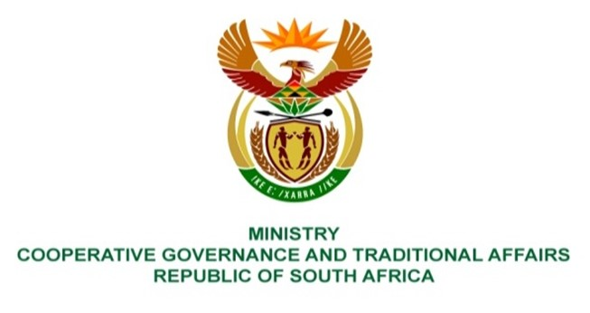

NATIONAL ASSEMBLY
QUESTION FOR WRITTEN REPLY

QUESTION NUMBER 1646
DATE OF PUBLICATION: 29 APRIL 2022

QUESTION:

1646. Mr D W Macpherson (DA) to ask the Minister of Cooperative Governance and Traditional Affairs:
What (a) total amount of her department’s budget has been spent on (i) infrastructure development and (ii) maintenance in the past five financial years, (b) percentage of the specified budget was spent on dealing with the COVID-19 virus, (c) total amount has been spent on drainage and flood alleviation measures and (d) total amount (i) of the infrastructure grants has eThekwini Metropolitan Municipality received in the past five financial years and (ii) has been returned to the National Treasury in each specified year? NW1973E

REPLY:
(a) (i) The Municipal Infrastructure Grant (MIG) is administered by the Department of Cooperative Governance with the aim of developing infrastructure to provide poor households with at least a basic level of service. Municipalities have been allocated R15,6 billion in 2021/22 that is aligned to the municipal financial year that will end on 30 June 2022.
Municipalities have reported expenditure on the MIG over the last 5 years 2016/17 - 2020/21) as follows:
Financial year | Transferred | Spent by receiving municipalities | % spent against transferred
2016/17 | 14,914,028 | 13,784,509 | 92.40%
2017/18 | 15,891,252 | 14,545,025 | 91.50%
2018/19 | 15,287,685 | 13,831,893 | 90.48%
2019/20 | 14,816,103 | 11,720,688 | 79.11%
2020/21 | 14,491,065 | 13,226,723 | 91.28%
Total | 75,400,133 | 67,108,838 | 89.00%

Disaster Grant contribution to Infrastructure Development (NDMC):
Funding allocations have been done from the Disaster Grants within the NDMC to augment resources of affected organs of state regarding infrastructure development: The funds were allocated from the Municipal Disaster Relief Grant, Provincial Disaster Relief Grant and Municipal Disaster Recovery Grant mainly in addressing the drought conditions in affected provinces and municipalities. The allocations were as follows:
Financial years | Type of grants | Amounts transferred | Purpose of allocation
2017/2018 | Municipal Disaster Relief Grant | R341 373 000 | Drought interventions: Infrastructure
 | Provincial Disaster Relief Grant | R78 000 000
2018/2019 | Municipal Disaster Recovery Grant | R 1 025 484 000
2019/2020 | No disaster grant allocations
2020/2021 | Provincial Disaster Relief Grant | R138 489 000
2021/2022 | Municipal Disaster Relief Grant | R 173 132 000
 | Provincial Disaster Relief Grant | R48 100 000
Total (infrastructure development) |  | R1 804 578 000
(ii) According to the MIG Framework, which stipulates the conditions under which the funds allocated to municipalities must be used, indicates that funds for the maintenance of roads must be in line with the maintenance priorities identified through the Rural Roads Asset Management System (RRAMS) administered by the Department of Transport. Although this provision has been made within the MIG no maintenance on roads maintenance has been funded form the MIG within the last 5 years.
(b) MIG receiving municipalities reported that:
- In 2019/20 MIG allocations were reprioritised in April 2020 to address Covid-19 related areas. The expenditure reported on projects was R204 million.
- In 2020/21 (period 1 July 2020 to 30 June 2022) MIG receiving municipalities reported expenditure of R609 million.

Disaster Grant allocation to Covid-19 response measures

Financial years | Type of grants | Amounts transferred | Purpose of allocation
2019/2020 | Provincial Disaster Relief Grant | R 466 392 000 | Covid-19 response measures
2020/2021 | Municipal Disaster Relief Grant | R150 970 000
Total (Covid-19) |  | R617 362 000
(c)
Financial years | Type of grant | Amounts transferred | Purpose of allocation
2016/2017 | No disaster grant allocations
2017/2018 | Municipal Disaster Recovery Grant | R26 147 000 | Interventions to sinkhole formation conditions
 |  | R16 304 000 | Interventions to storm damages
2018/2019 |  | R200 654 000
2019/2020 | No disaster grant allocations
2020/2021 | Municipal Disaster Relief Grant | R157 137 000
Total (flood and storm damage interventions) |  | R400 242 000

(d) (i) The total amount of R14,7 billion was transferred to the eThekwini over the last 5 years and (ii) R909 million had to be returned to the National Fiscus.

The eThekwini Metropolitan Municipality has received various grants (conditional and unconditional) from the national fiscus over the last five years to assist with infrastructure development. They are:
- Municipal Emergency Housing Grant
- Neighbourhood Development Partnership Grant
- Integrated National Electrification Programme (Municipal) Grant
- Energy Efficiency and Demand Side Management Grant
- Municipal Disaster Recovery Grant
- Public Transport Network Grant
- Urban Settlements Development Grant
- Integrated City Development Grant

Financial tear | Grants received | Actual Expenditure reported | Total unspent | Approved Rollover | Amount to be returned
2016/17 | 2,976,972 | 2,948,818 | 28,154 | - | 28,154
2017/18 | 3,036,370 | 2,700,090 | 336,280 | 554 | 335,726
2018/19 | 2,984,325 | 2,482,135 | 502,190 | 2,662 | 499,528
2019/20 | 3,189,069 | 3,120,680 | 68,389 | 32,449 | 35,940
2020/21 | 2,515,345 | 2,497,398 | 17,947 | 8,528 | 9,419
Total | 14,702,081 | 13,749,121 | 952,960 | 44,193 | 908,767
National Treasury
(ii) The total amount of R908.7 million was recorded as unspent conditional grants by the National Treasury (this amount has since returned to the NRF). This amount excludes the grants allocated for operational purposes, unconditional grants, indirect grants and the rollover approved amount of R44.2 million.

