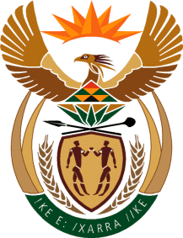

MINISTRY OF TOURISM
REPUBLIC OF SOUTH AFRICA

Private Bag X424, Pretoria, 0001, South Africa. Tel. (+27 12) 444 6780, Fax (+27 12) 444 7027
Private Bag X9154, Cape Town, 8000, South Africa. Tel. (+27 21) 469 5800, Fax: (+27 21) 465 3216

Ref: TM 2/1/1/10

NATIONAL ASSEMBLY:
QUESTION FOR WRITTEN REPLY:
Question Number: 1643
Date of Publication: 9 June 2017
NA IQP Number: 21
Date of reply: 22 June 2017

Mr J Vos (DA) to ask the Minister of Tourism

(1) What are the budgets for the (a) Shangoni Gate, (b) Phalaborwa Wild Activity Hub and (c) National Heritage Monument Park destination enhancement or development projects;
(2) Whether any of the specified projects are running over budget currently; if so, what are the (a) cost over-runs to date and (b) reasons for the cost over-runs in each case? NW1849E
Reply:
- What are the budgets for:
Project | Budget from NDT
- Shangoni Gate | R25 million
- Phalaborwa Wild Activity Hub | R25 million
- National Heritage Monument Park | R10 million

- Whether any of the specified projects are running over budget currently:
- What are the cost over-runs to date?
None
- What are the reasons for the cost over-runs in each case?
N/A

