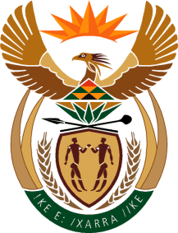

MINISTRY OF TOURISM
REPUBLIC OF SOUTH AFRICA

Private Bag X424, Pretoria, 0001, South Africa. Tel. (+27 12) 444 6780, Fax (+27 12) 444 7027
Private Bag X9154, Cape Town, 8000, South Africa. Tel. (+27 21) 469 5800, Fax: (+27 21) 465 3216

Ref: TM 2/1/1/10

NATIONAL ASSEMBLY:
QUESTION FOR WRITTEN REPLY:
Question Number: 1641
Date of Publication: 9 June 2017
NA IQP Number: 21
Date of reply: 7 July 2017

Mr G R Krumbock (DA) to ask the Minister of Tourism

Whether she has established the reasons why the average length of stay to 4,3 nights and resulting bed nights has grown in 2016 compared to 2015, despite the fact that the number of trips declined by 0,7% over the same period; if so, what are the relevant details? NW1847E

Reply:
The decrease in domestic trips in 2016 was largely driven by the shift in holidays, negatively impacting on the number of trips taken with a purpose of visiting family and friends. Although fewer trips were taken in 2016 compared to 2015, domestic tourism survey indicates that tourists stayed longer relative to 2015. The average length of stay per trip increased by 1.6%, leading to an increase in the total number of bed night by 0.9%. The reasons for this increase despite the decline in the total number of trips was due to the fact that during 2016, more public holidays were close to weekend resulting in domestic tourists opting to combine the holidays with those weekends for their trips, hence the longer duration of stay for those who undertook the trips.

