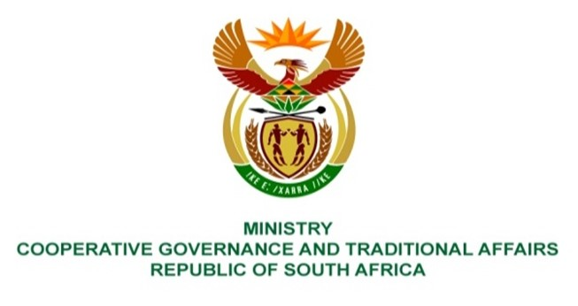

NATIONAL ASSEMBLY
QUESTION FOR WRITTEN REPLY

QUESTION NUMBER 1638
DATE OF PUBLICATION: 12 MAY 2023

1638. Ms H Ismail (DA) to ask the Minister of Cooperative Governance and Traditional Affairs:
(a) What innovative and proactive measures are being considered and/or have been implemented to urgently and effectively combat the ongoing issue of cable theft and minimise its impact on residents' access to electricity and (b) in what manner is the Government working in collaboration with stakeholders, such as law enforcement agencies, private sector partners and local communities, to ensure a comprehensive and sustainable approach to eradicating the pervasive problem in the future? NW1879E
REPLY:
The criminal component of cable theft and damage is dealt with by the South African Police Service.
End.

