# NATIONAL ASSEMBLY

**FOR WRITTEN REPLY**

**QUESTION NO. 1634**

**DATE OF PUBLICATION IN INTERNAL QUESTION PAPER: 22 NOVEMBER 2019**

**(INTERNAL QUESTION PAPER NO. 29)**

**Dr M M Gondwe (DA) to ask the Minister of Health:**

(1) What progress has his department made in implementing the National Strategic Plan for HIV, TB and STIs 2017 – 2022;

(2) how does his department intend to address the issue of noncommunicable diseases that have been identified as forming part of the quadruple burden of diseases;

(3) what (a) number of Gene Xpert TB diagnosis machines has his department acquired, (b) is the coverage of the machines and (c) has he found to be the impact of the machines on TB (i) testing and (ii) treatment?

**NW2991E**

###### REPLY:

(1) The South African National AIDS Council secretariat is currently finalising the midterm report against activities and targets set in the National Strategic Plan, 2017-2022. Highlights of the review were presented, on 23 November 2019, to the SANAC Extended Plenary meeting, co-chaired by the Deputy President and Ms Steve Letsike representing civil society. Once the midterm report is finalised copies can be made available to Members of Parliament.

In brief, South Africa has made progress against the various pillars of Strategic Plan as reflected by data on reduction in new infections as well as access to antiretroviral treatment. With respect to HIV incidence, the number of new infections has fallen from 270,000 in 2012 to 222,000 in 2018. Whilst this reduction is welcome it is clearly too slow and more needs to be done to reduce new infections.

The mother to child transmission rates at 10 weeks postpartum have declined to 0.74% which means that fewer children are being born HIV positive. Although condom distribution has increased, condom utilisation is on the decline, particularly in the 15-24 year old age group. Combination prevention and differentiated service delivery, addressing the needs of each target population in a more holistic and comprehensive way, has been prioritised.

In terms of treatment, South Africa has reached the 5 million people on treatment. The majority of the patients are in the public sector (4.8 million) with the remainder in the private sector. With respect to the UNAIDS 90-90-90 targets (90% of people with HIV know their status, 90% of these on treatment, and 90% of those on treatment virally suppressed), the country has reached 91-71-88. This means that South Africa has achieved the 1st 90, and is steadily progressing towards achieving the 2nd and 3rd 90’s. Three districts (in KwaZulu-Natal) have reached the 90-90-90 targets with another 14 nation-wide likely to reach this target by March 2020.

We need to test and treat more men and young people and retention on treatment continues to be a challenge which government and its partners are working on. Internal and external migration together with a lack of an electronic information system across the health system are contributory to a higher than acceptable percentage of patients retained in care.

The burden of tuberculosis remains large with South Africa being one of the high burden countries. We have recently completed the first ever national TB prevalence survey and the results are currently being verified by the World Health Organisation. Once verified we will have a better understanding of the TB incidence and prevalence rates. The TB prevalence survey report can also be made available to Members of Parliament once finalised. From routine data we know that notifications are on the decline but that we are still missing an estimated 160,000 patients – as for HIV, we are missing young people as well as men. Efforts are underway to intensify screening, testing and initiation of young people and men on treatment and finding the missing TB patients.

(2) The Department intends addressing the issue of non-communicable diseases that have been identified as forming part of the quadruple burden of disease through the National Strategic Plan on Non-Communicable Diseases 2020-2035 which is in the process of being approved. This Strategy aims to strengthen existing initiatives on the prevention and control on non-communicable diseases (NCDs). Such initiatives include:

**PREVENTION AND PROMOTION**

South Africa has taken a number of legislative/regulatory/policy steps to prevent NCDs. Specific preventive interventions include (by main risk factors):

**Tobacco**

a. A new Draft Control of Tobacco Products and electronic Delivery Systems Bill has been tabled;

b. The key areas that the Bill will regulate are:

- restrictions on public smoking;

- the sale and advertising of tobacco products and electronic delivery systems;

- the prohibition on financial or other support;

- the prohibition of vending machines;

- the standardisation of the packaging and appearance of tobacco products; and electronic delivery systems; and

- restriction on the sale of products.

**Diet**

a. A regulation on Trans-fats in Foodstuffs was passed in 2011 (R127). According to this regulation the trans-fat content of any oils and fats cannot exceed two grams per 100 grams. Products with higher trans fats levels are prohibited from entering or being sold in the country.

b. A regulation on reduction of sodium in 13 categories of foodstuffs that are the most common source of sodium for the majority of South Africans was passed in 2013 (R214) and amended in October 2017.

c. A levy on sugar sweetened beverages (Health promotion levy) was passed in 2018. The levy is foxed at 2.1 cents per gram of sugar content that exceeds 4g per 100ml. Fruit juice is exempt.

d. South Africa adopted a Strategy for the Prevention and Control of Obesity in South Africa (2015-2020).

e. National Nutrition Week and National Obesity Week took place annually from 09 to 15 and 15 to 19 October respectively. For the past three years (2016, 2017 and 2018) the Department of Health campaigns focused on the importance of eating regular, healthy meals to prevent obesity and consequently non-communicable diseases and to promote health.

**Physical activity**

a. The Country commemorates the Move for Health campaign on an annual basis on the 10th of May. The campaign is led by the Sport and Recreation South Africa in collaboration with the Department of Health.

b. The Department of Sports and Recreation hosts an annual Big Walk on the first Sunday of October each year. The Big Walk is the South African version of the World Walking Day. Since 2012 it has taken place in all provincial capital cities with more than thirty thousand (30,000) participants in 2017.

c. The Cabinet of South Africa also declared the first Friday of October as the National Recreation Day since 2014. The campaign is targeting all Citizens to be physically active.

**The Human Papilloma Virus (HPV) vaccination programme**

a. The Human Papilloma Virus (HPV) vaccination programme was launched in 2014 by the National Department of Health in partnership with the Department of Basic Education, as part of primary prevention against cervical cancer.

b. The aim was to target an estimated 550,000 girls in grade 4, aged 9 years in 17,000 public and special schools, before they were exposed to HPV infection.

c. A bivalent vaccine (Cervarix) is given at five to six month intervals using a campaign approach implemented through the Integrated School Health Programme.

d. The first round is conducted during February to March and the second round in August to September of each year.

e. Between 2014 when this programme started and February 2019 a total of one million nine hundred and thirty four thousand six hundred and thirty five (1,934,635) Grade 4 girls had received Dose 1 and one million two hundred and seven thousand four hundred and seventy seven (1,207,4077) Dose 2.

**HEALTH SYSTEMS IMPROVEMENT**

a. An Integrated Clinical Services Management Model that incorporates all chronic diseases, whether communicable or non-communicable, was introduced through the Ideal Clinic initiative. This means that patients are seen for whatever chronic disease they have, including for multiple conditions, at the same visit. As of 2018, 97,2% of clinics had reorganized with designated consulting areas for management of chronic conditions and had patient appointment systems for people with chronic conditions (up from 87% and 73% respectively in 2017).

b. Medicine for many patients that are stable on Non Communicable Diseases medication are provided through the Centralised Chronic Medicines Dispensing and Distribution (CCMDD) model.

c. Together with the Affordable Medicines Directorate (AMD), concerted efforts have been made to improve drug availability at hospital and primary care levels and systems are in place to monitor medicine stock outs.

(3) (a) **Table 1: The provincial distribution of GeneXpert devices in South Africa**

|  |  |  |  |  |  |
| --- | --- | --- | --- | --- | --- |
| PROVINCE | GX4 | GX16 | GX48 | GX80 | Total |
| Eastern Cape | 17 | 28 | 0 | 2 | 47 |
| Free State | 11 | 9 | 0 | 1 | 21 |
| Gauteng | 25 | 27 | 1 | 2 | 55 |
| KwaZulu-Natal | 25 | 51 | 0 | 1 | 77 |
| Limpopo | 19 | 25 | 0 | 0 | 44 |
| Mpumalanga | 3 | 14 | 0 | 1 | 18 |
| North West | 8 | 17 | 0 | 0 | 25 |
| Northern Cape | 2 | 6 | 0 | 0 | 8 |
| Western Cape | 17 | 13 | 0 | 1 | 31 |
| Total | **127** | **190** | **1** | **8** | **326** |

(3) (b) The National Health Laboratory Services (NHLS) laboratory were mapped in Figure 1 to show the coverage of laboratories in South Africa. This was generated using Global Positioning System (GPS) coordinates provided by the National Priority Programme (NPP).

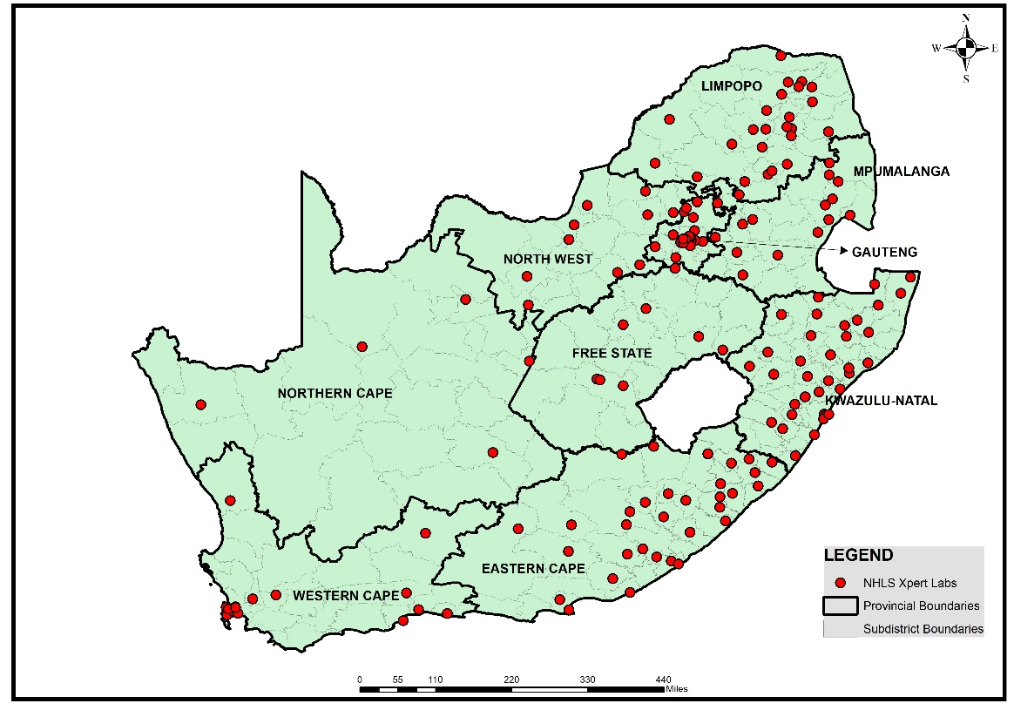

**Figure 1: The geographic coverage of NHLS laboratories across South Africa**

(3) (c) (i)-(ii) The impact of GeneXpert has been:

- Early diagnosis of TB and initiation of treatment resulting in reduction in deaths from 33,300 patients (in 2011) to 16,133 (in 2017), a 51% reduction in deaths due to TB;

- The universal drug susceptibility testing for all patients has enabled early triage of patients with rifampicin resistant TB to appropriate second line treatment. This has resulted in a reduction in treatment failure from 5 062 (in 2011) to 934 (in 2017); and

- Reduction in number of patients hospitalised for DS and DR-TB, saving on hospitalisation costs.

Figure 2 summarises the progress of the GeneXpert program over time from March 2011 to September 2019. This was generated using the monthly data provided to the Research and Development team by the NPP. The figure shows a general decrease of both Mycobacterium Tuberculosis (MTB) detection (despite seasonal trends of increased MTB detection in the winter months) and Refampicin-resistant Tuberculosis (RIF) resistance. The “trace”/MTB Indeterminate rate is relatively consistent.

The yearly NPP reported figures for the GeneXpert program are shown in Tables 2 and 3. Table 2 shows the operational programmatic indicators for test outcomes. Table 3 shows the RIF outcomes for MTB detected tests.

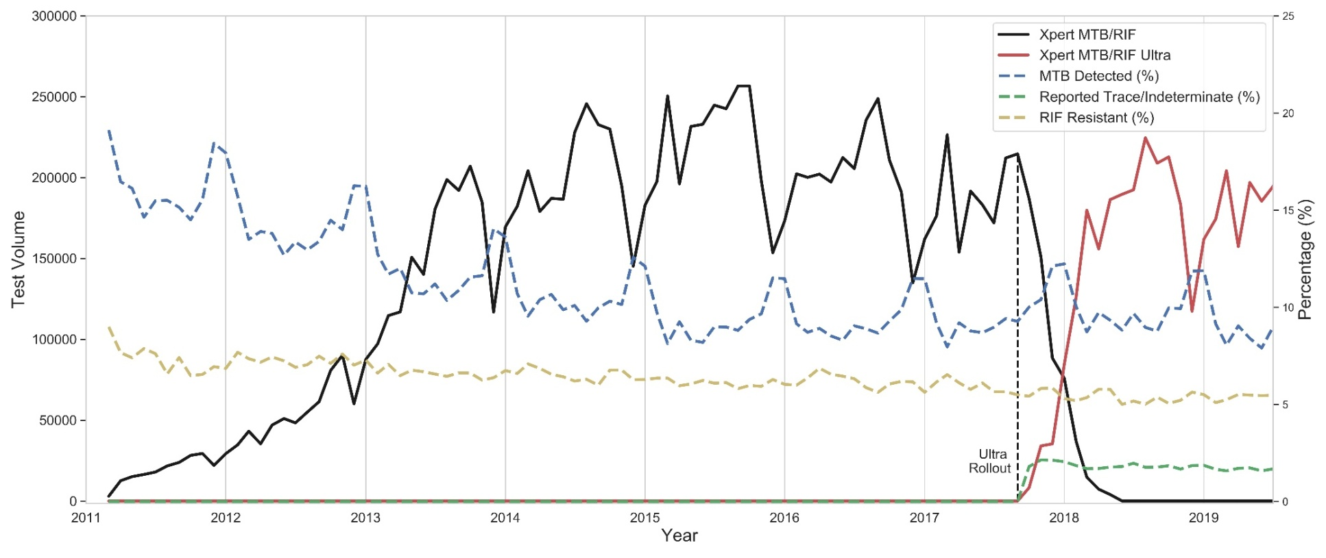

**Figure 2: The temporal progression of the GeneXpert program at national level. The figure shows the number of tests (for both Xpert MTB/RIF and Xpert MTB/RIF Ultra), the MTB detection rate, “trace”/MTB Indeterminate rate and RIF resistance rate**.





END.